Kondgaon Visit
Dental & Oral Hygiene Awareness Camp
Dental Kit & Sanitary Napkin Distribution
24/04/2022

Oral health plays a vital role in the overall health and wellbeing of the individual. With the objective of helping kondgaon villagers' access oral health and hygiene facilities, MSR Committee conducted a free dental check-up and awareness camp in association with Denta Zone on 24th of April, 2022 at Kondgaon Village. Also, free dental kit and sanitary napkins were distributed.
Objective of the visit:
- Free dental check-up
- Distribution of Toothbrush & Tooth paste to each villager. ​
- Guidance to the patients about the food intake and daily routine they should follow to prevent dental disorders.
- Awareness among the villagers on oral hygiene.
- Distribution of Sanitary Napkins
- Awareness regarding menstrual health.
Under the guidance of Dr. Aditi Mahale & Dr. Yogesh Mahale, 150 villagers including children & adults were benefitted. Dr. Aditi demonstrated correct way to brush the teeth twice in a day. Also, the doctors guided the patients about the food intake and daily routine they should follow to prevent dental disorders.
Mrs. Manju Kombh, Sarpanch of Kondgaon village, played an instrumental role for making this camp successful by informing the villagers one week before the camp. Also, teachers of all the 6 Zila Parishad School provided their support to make this camp beneficial for the students.
Team MSR is grateful for all the support and guidance provided by CEO Mam, Director Sir & Faculty members. We also thank, Operations Team, Accounts Department, Marketing Team, Administrative staff and Support staff.
Team MSR
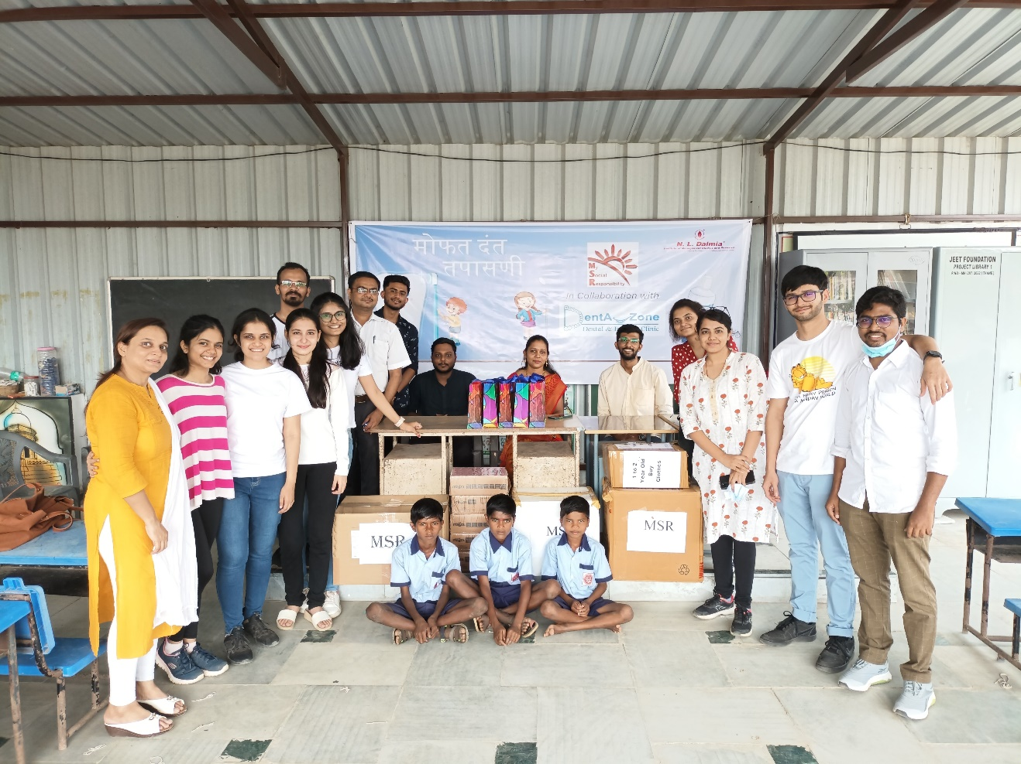
Dr. Yogesh Examining the Villagers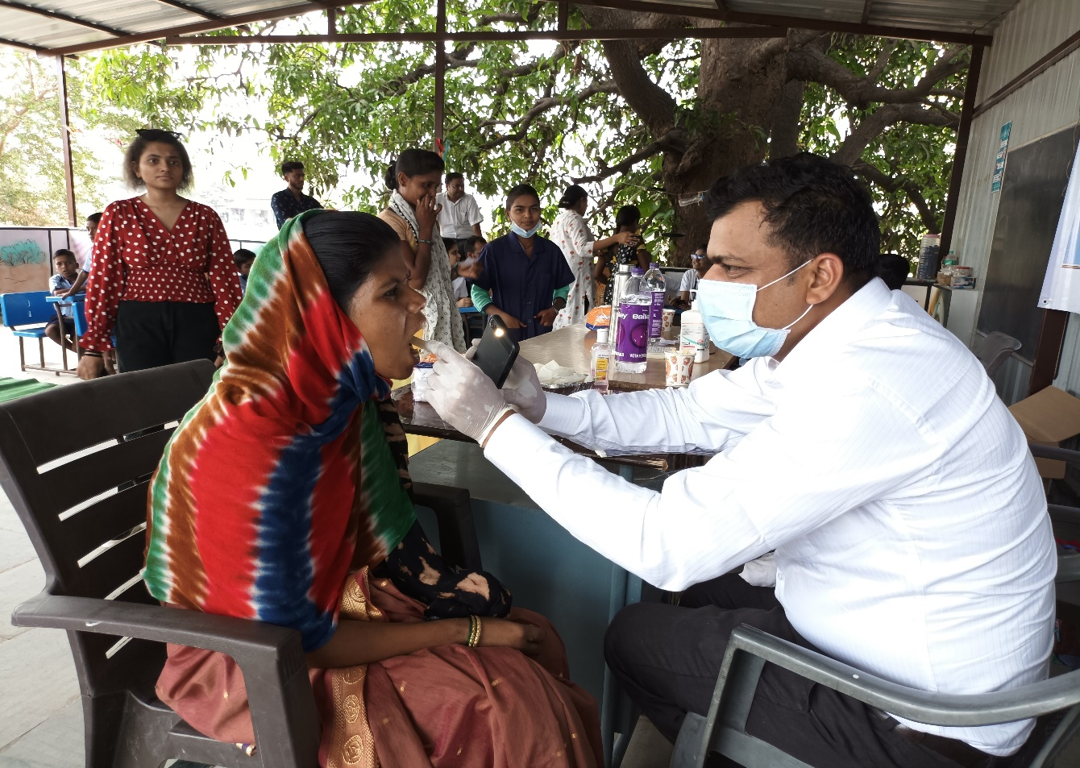
Dr. Aditi Educating the Villagers about Oral Health
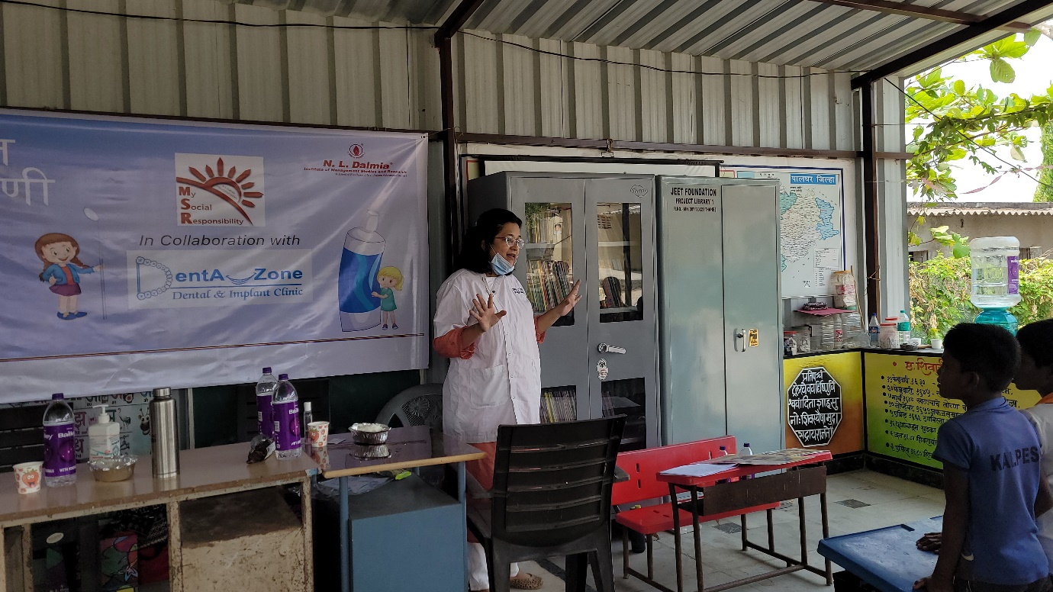

Distribution of Sanitary Napkins
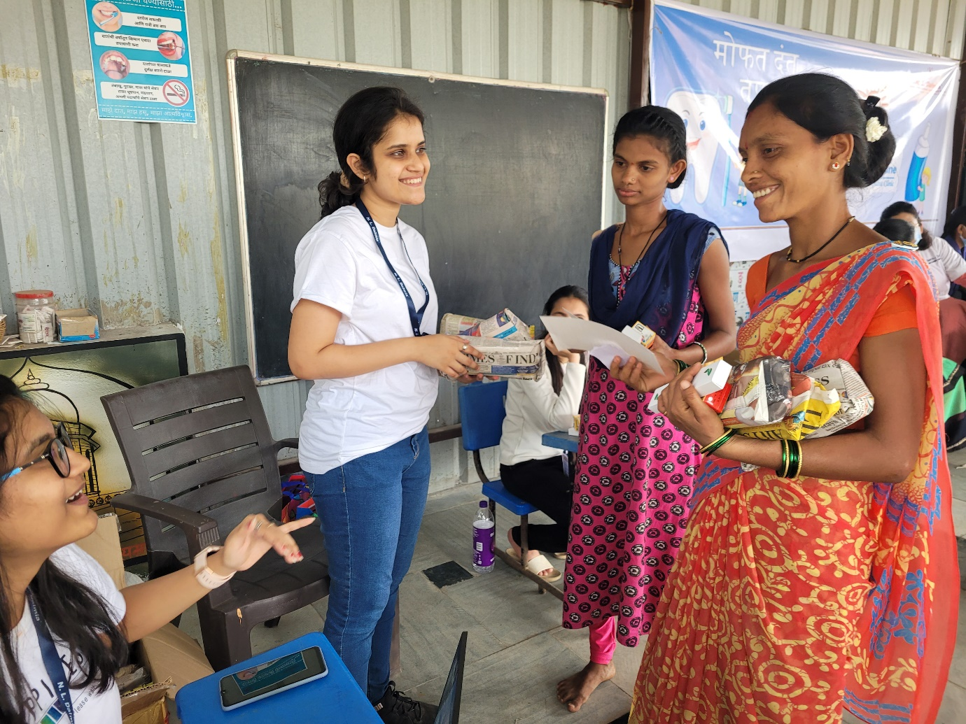

Distribution of Oral Kits
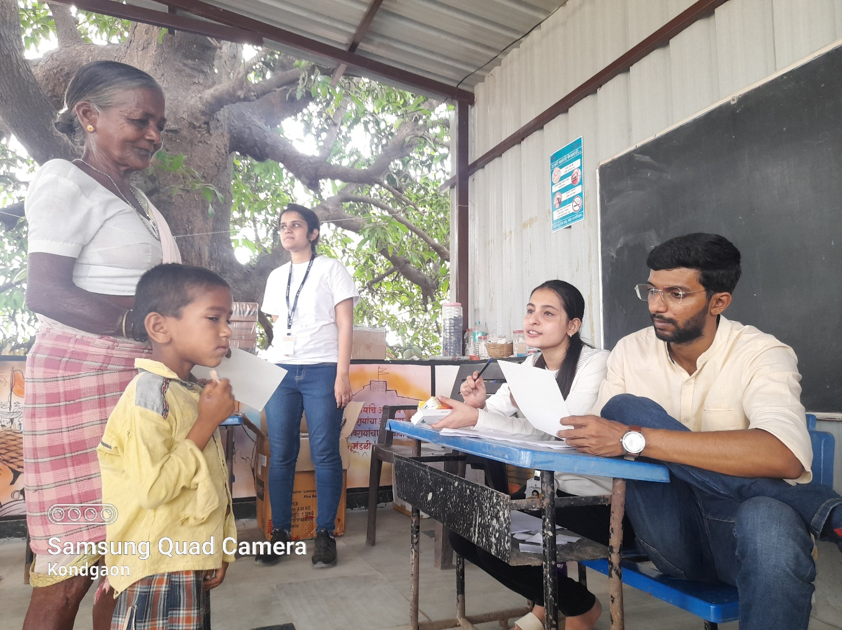

Smiling Faces
