Rural Immersion Programme at Kondgaon
30/07/2022 & 2/08/2022

MSR committee in association with KKPS foundation conducted Rural Immersion Program at Kondgaon for PGDM and Global MBA batch 2022-24 as part of induction week on 30/07/2022 & 02/08/2022. Following verticals were covered during the visit:
- Education - Learning activities and Stationary Distribution Camp
- Healthcare and Hygiene - Sanitary Napkin Distribution and Menstrual health awareness Camp
- Environment - Tree Plantation & Net Guard for kitchen garden at ZP Rawatalpada School
- Skill Development - Project Sarthi Session and Career Guidance for students of 10th to 12th.

Over 250+ students contributed towards the activities executed in different schools of Kondgaon. Following are the brief of activities conducted:

- Stationary distribution to 200+ primary students of ZP School at Rawatalpada, Gondpada & Goratpada.
- Distribution of 400+ Packets of Sanitary Napkins to 350+ girl students at Shanti Ratan School, Kondgaon under Project Garima.
- Seminar on Menstrual Hygiene conducted by Ms. Pooja Anchan, Executive – Corporate Relations & MDP at NLDIMSR.
- Seminar on Career Counselling under Project Saarthi provided to 100+ students of 11th & 12th Standard.
- 50 saplings planted around the school campus of Shanti Ratan School & ZP Rawatalpada school. Also the vegetable garden was fenced to keep the vegetable safe from domestic animals.
- Drawing Sessions and Puzzles session conducted for 200+ primary students.
- Dance & story telling sessions conducted for 50+ pre-primary students for ZP Rawatalpada school.

Mr. Sagar played an instrumental part in overall arrangements for the visit. Dr Neeraj Gupta, Prof. Minati, Prof. Prakash Rathod, Mr. Anish Shetty, Ms. Pooja and Ms. Palak joined and supported Team MSR in all the activities.

This event was coordinated under the guidance of Induction Programme Faculty Coordinator Prof. Anand Dhutraj & MSR faculty-in-charge Dr. Nazia Ansari and planned, executed, & managed by Team MSR.

Dr. Nazia Ansari
MSR Faculty Coordinator
Project - Saarthi
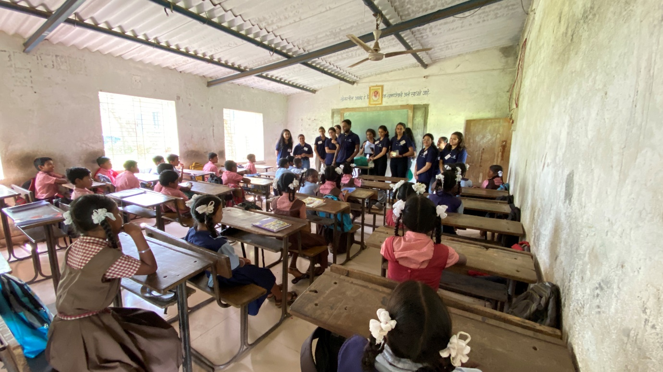

Career Counselling for 10th Students
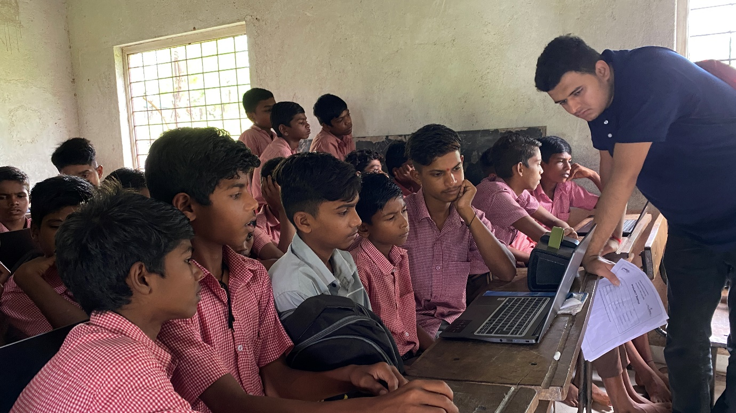

Drawing Sessions
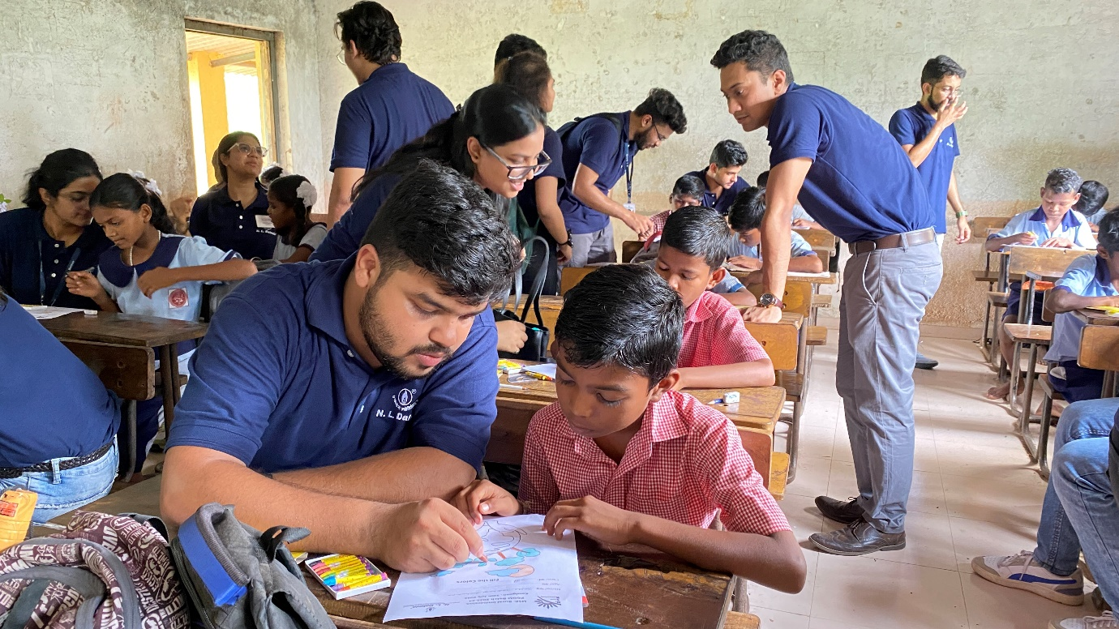

Learning with Fun organized for Primary Students
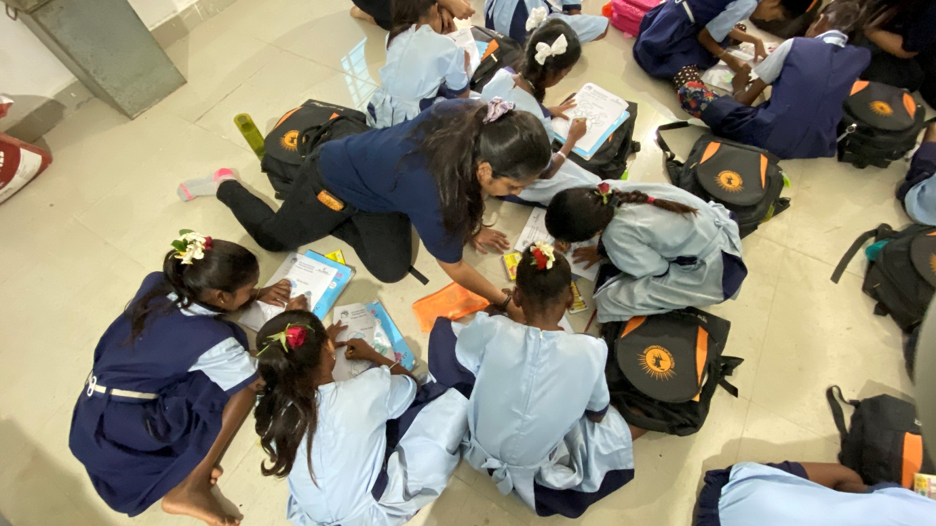

Story Telling Session
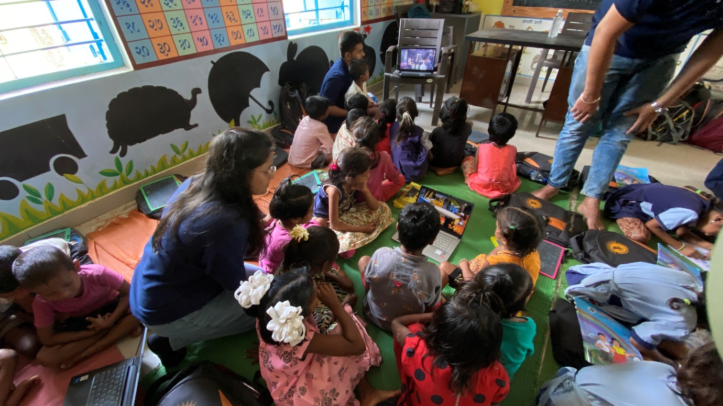

Maths Session

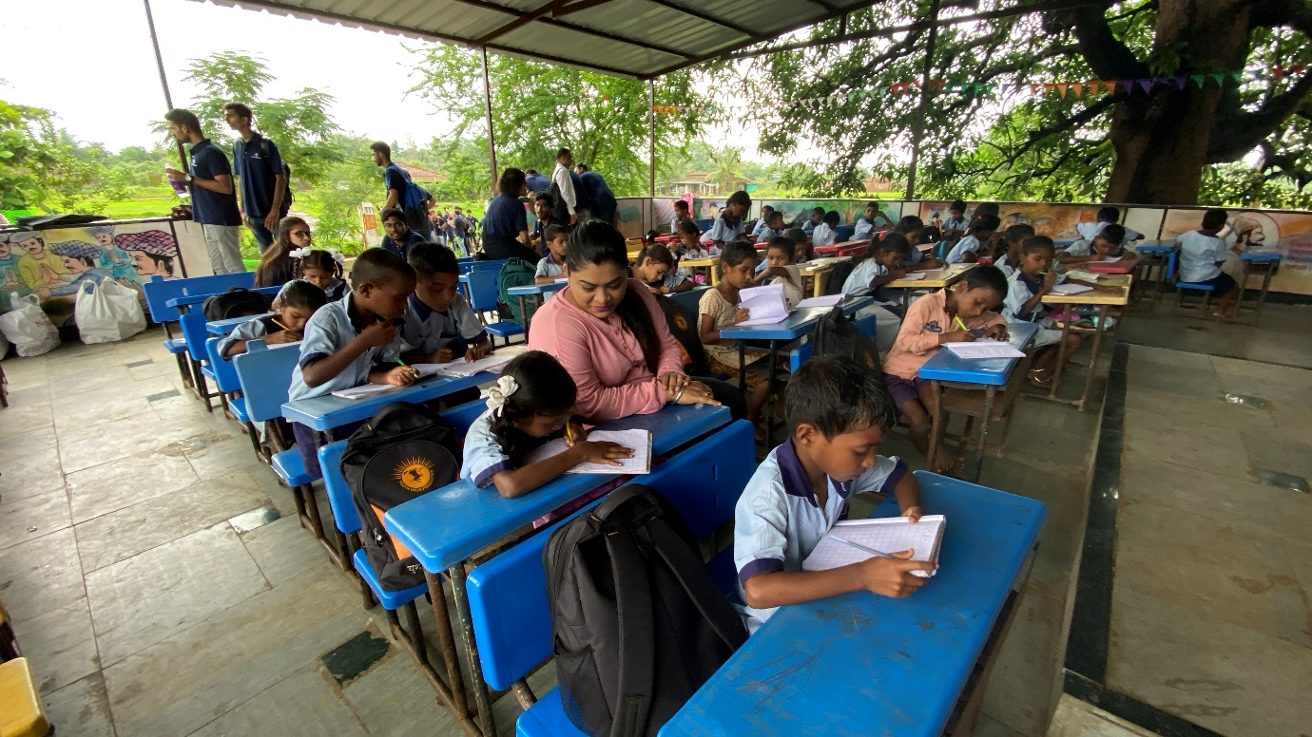

Menstrual Hygiene Awareness Seminar

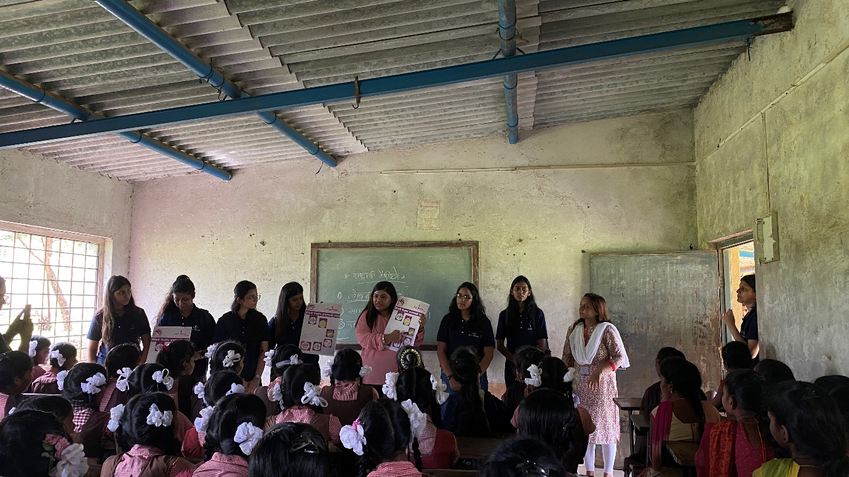

Sanitary Napkin Distribution
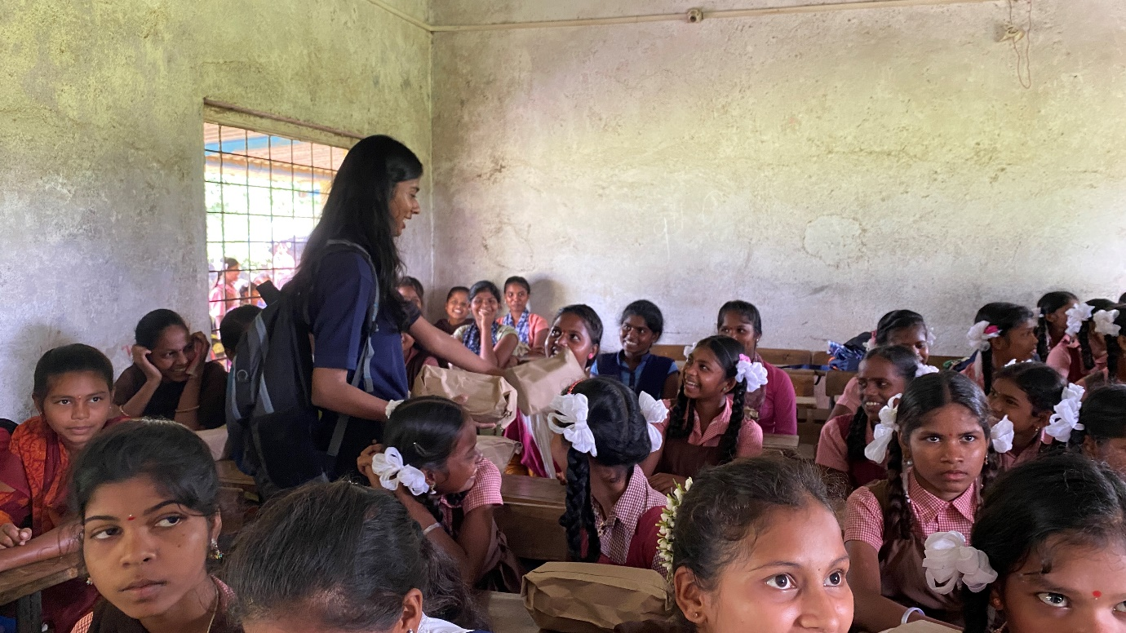

Tree Plantation with Kondgaon Sarpanch
Mrs. Manju Komb & MSR Faculty Coordinator Dr. Nazia Ansari

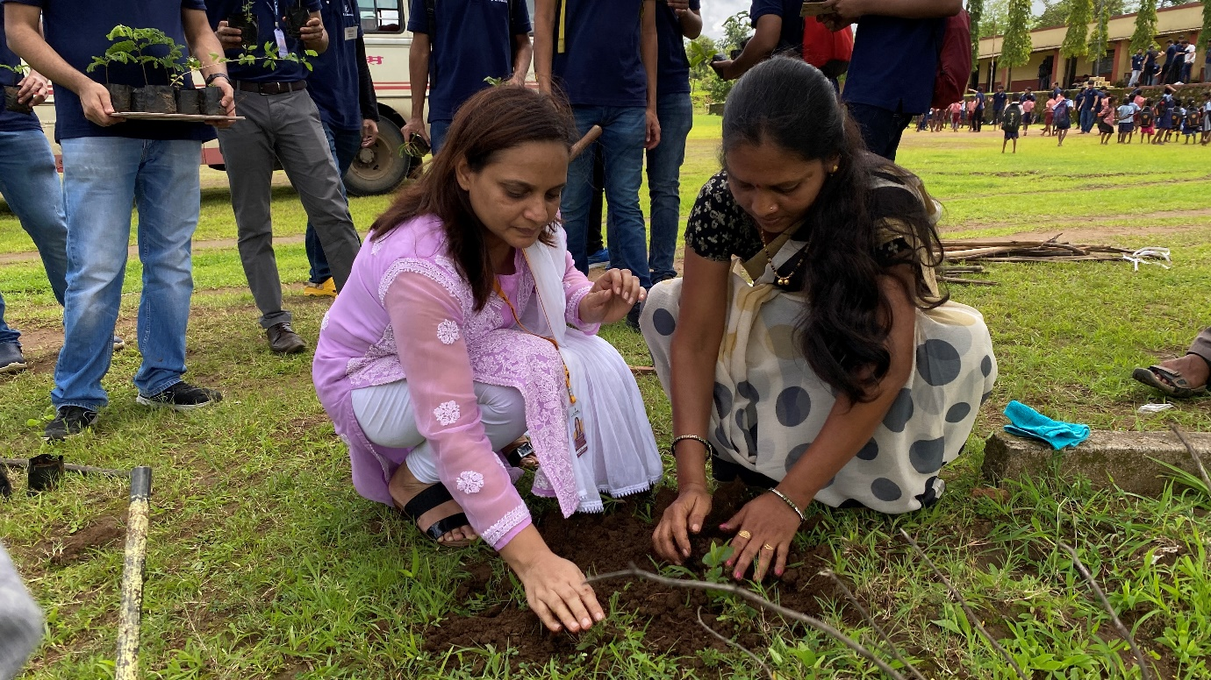

Tree Plantation by PGDM Batch 2022-24 Students

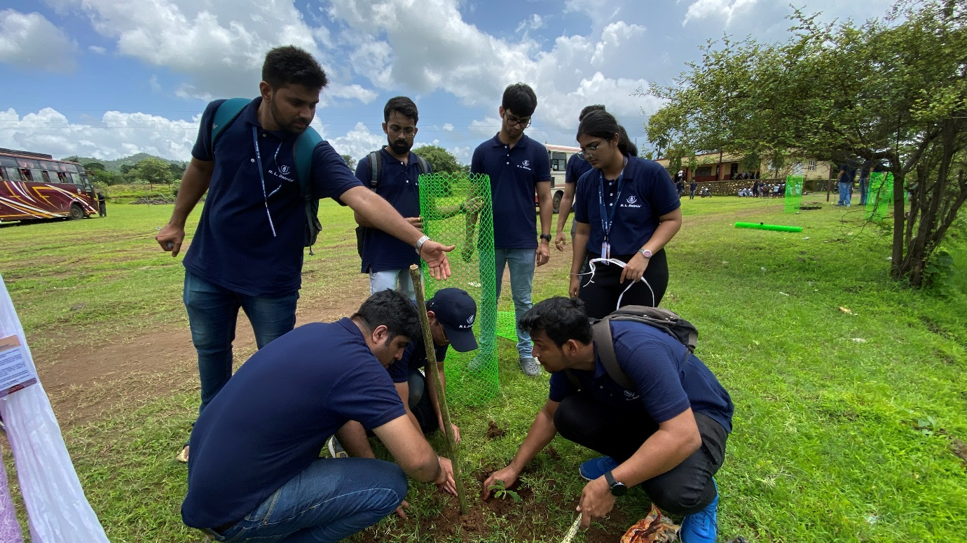

Tree Saplings Fencing

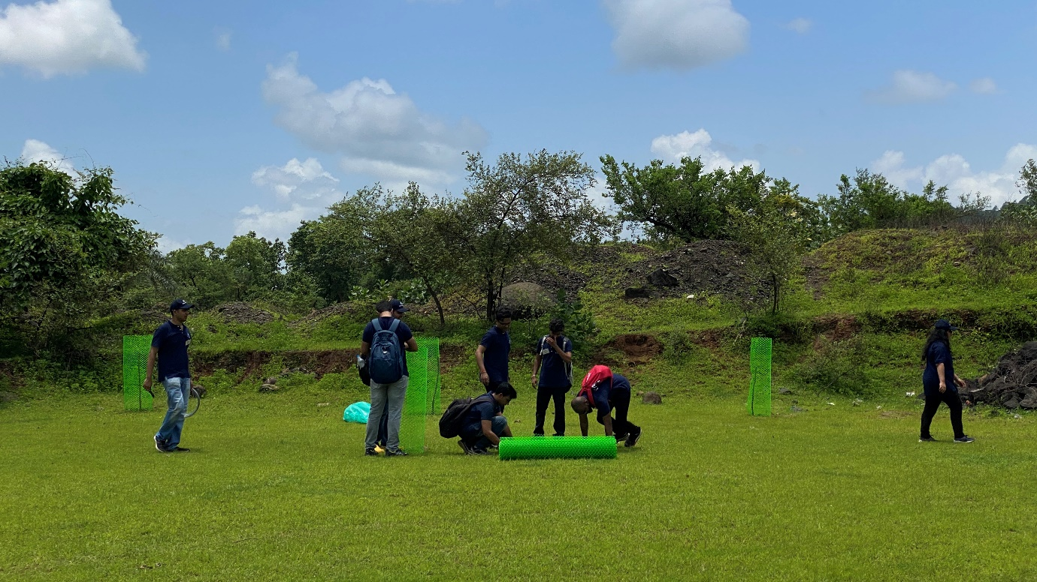

Kitchen Garden Fencing

