My Social Responsibility (MSR) Activities | 30th December 2021 | Vertical – Hygiene & Health  New Year Celebration with schools kids

MSR committee organised a visit to Kondgaon village on 30th December 2021, Thursday. It was an introductory visit for the new MSR team members of 2021-23 PGDM batch. Following activities were conducted covering Hygiene & Healthcare and Education Verticals
- Celebration of New Year with the students of Main School at Kondgaon.
- Engaged the students with the help indoor & outdoor games.
- Distributed sanitary napkins & conducted a seminar on menstrual hygiene awareness.
- Collected information regarding the requirement of the village to plan future course of action.
The objective of the visit was :
- To make the students (girls) of kondgaon understand the importance of hygiene during menstruation.
- To welcome the new year – 2022 with smiles and hopes.
- To sensitize the PGDM 1st and 2nd year students about the requirement of village.
The schedule of the visit was as below:
Timing | Particulars
7.30 am | Depart from College Campus
10.00 am - 12.00 pm | Christmas & New Year Celebration
12.00 pm - 2.30 pm | Learning activities (Parallelly with different teams)
3:00 pm - 4:00 pm | Sanitary Distribution to Girl Students with Awareness Seminar
4:00 pm - 5:00 pm | Interaction with Sarpanch & School Teachers
5:00 pm onwards | Back to NLDIMSR
Team MSR conversed with the students and played indoor games to create atmosphere of new year celebration. Meanwhile discussion was in progress with the Head and Principal of school Mr. Dukhale, Mr. Ravindra Patil and Mr. Sambhaji Dighe for identifying the requirement of students.
Distribution of Following things occurred during the visit:
- 450 Food Boxes to Students & Teachers of Shanti Ratan Vidyamandir, Kondgaon
- 600+ packets of sanitary napkins to 300+ girls for 3 months.
- 100 Sanitizers bottle of 250ml.
Activities Conducted:
- Menstrual Hygiene Awareness Seminar.
- Indoor-Outdoor Games to engage the students.
- Story Telling Session
- Interaction with Sarpanch Mrs. Manju Kombh & Teachers of School to understand the future requirement.
Learning Outcomes:
- PGDM students were able to understand the plight of girls during menstruation as they come from poor families hence not able to buy napkins.
- They learned about the hardships of the village people and were determined to put more efforts for sustainable development.
- It was a walk down the memory lane as all the students remembered the games they used to play in schools.
- Overall the objectives of the visit were accomplished of serving the society.

Faculty-in-Charge – Dr. Nazia Ansari

Distribution of Food Packets
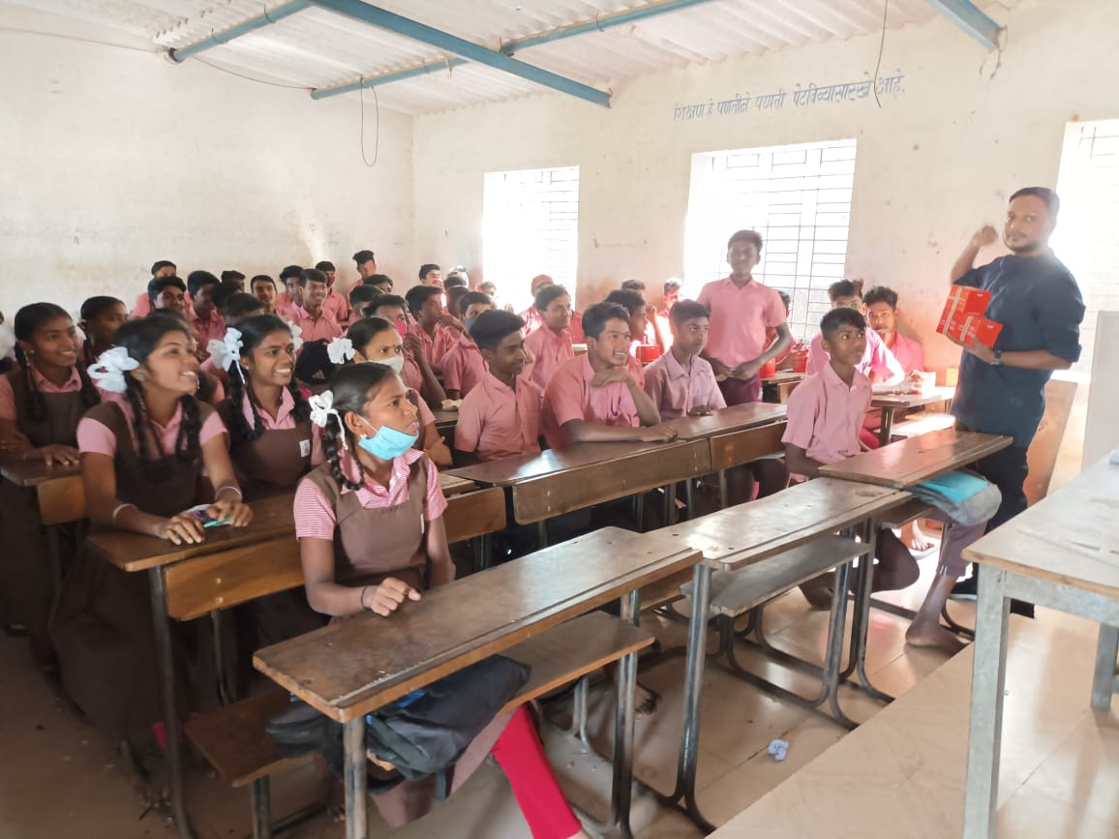
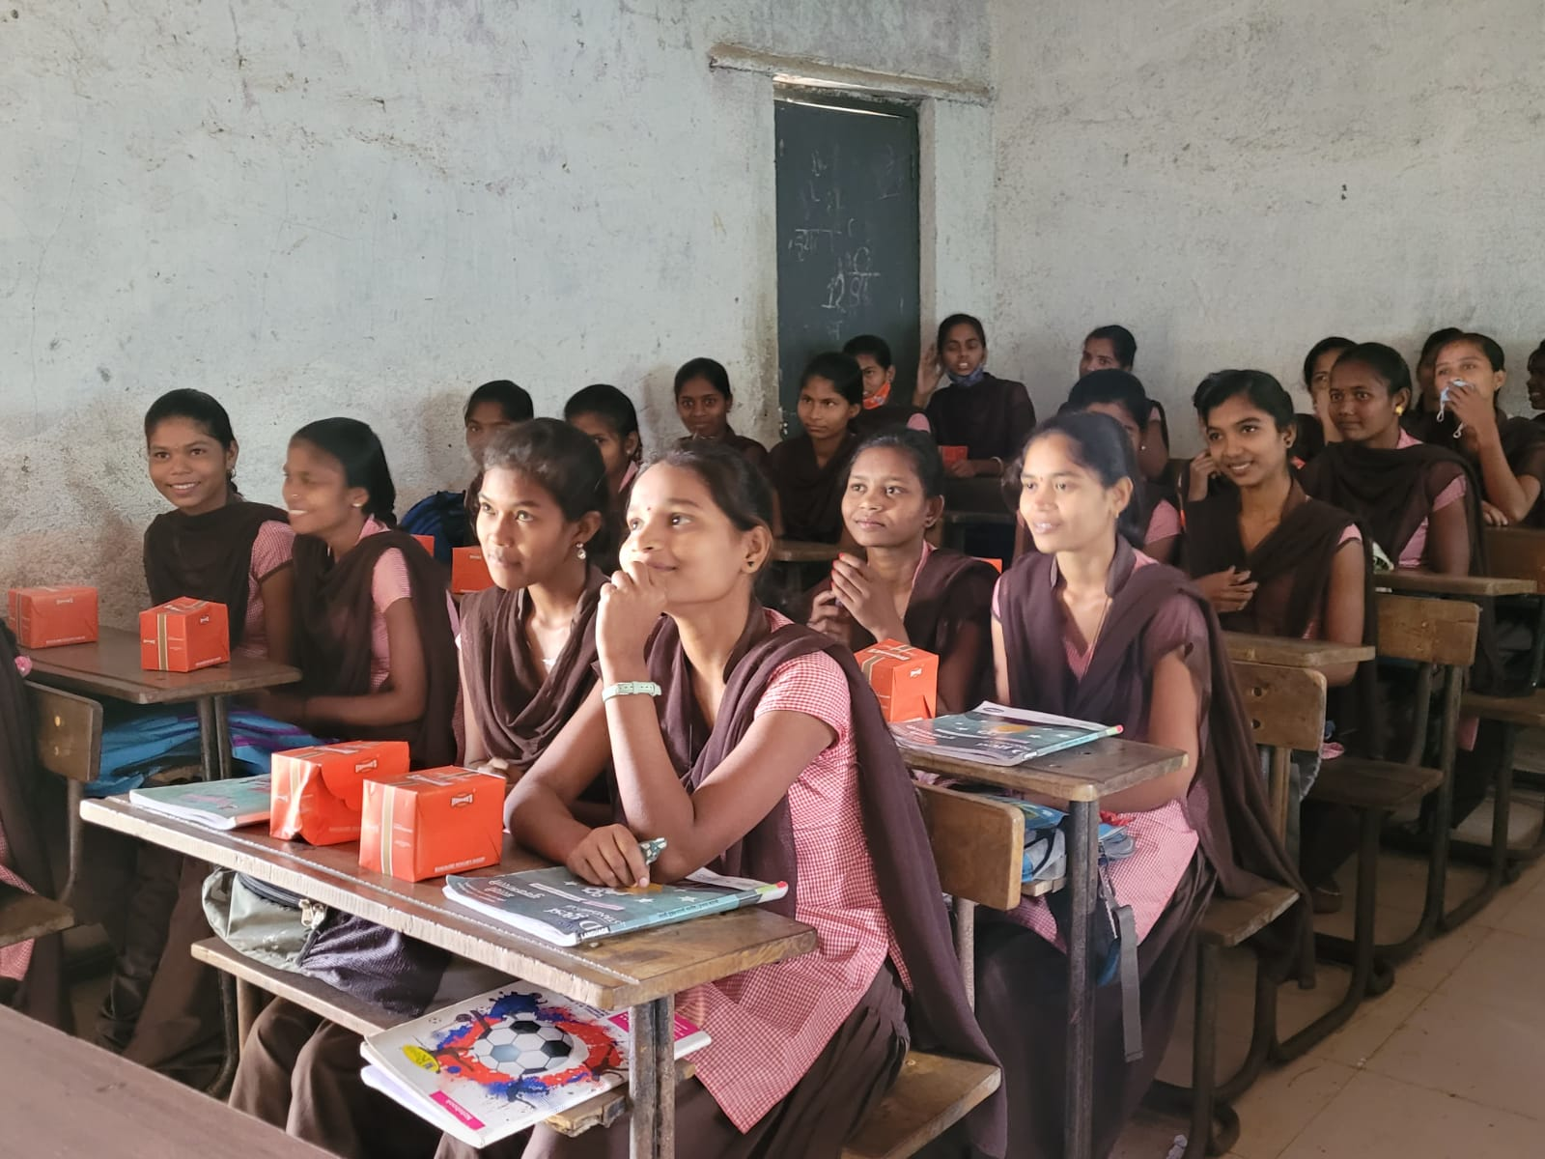

Distribution of Sanitary Napkins

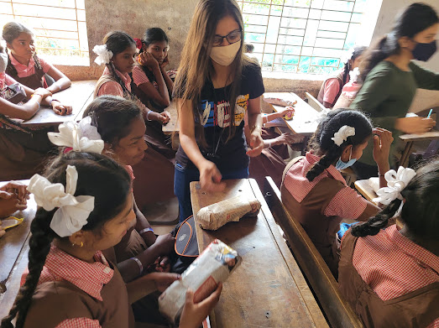
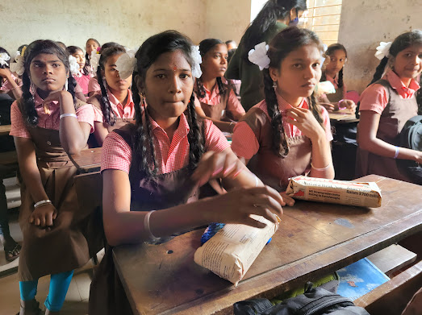

Seminar on Menstrual Hygiene Awareness for 6th – 12th Standard Girls
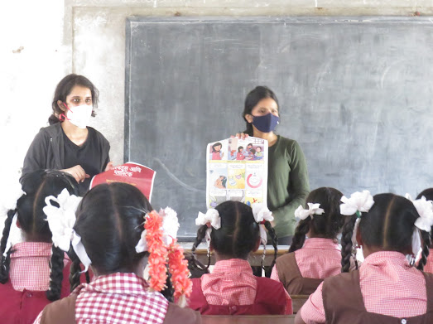

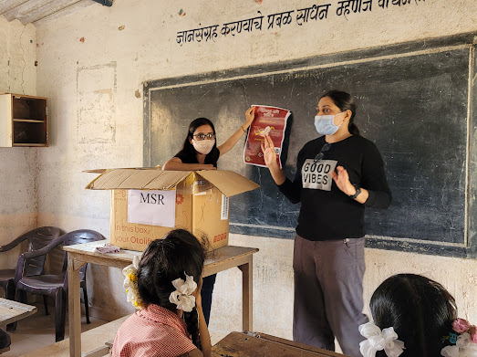

Indoor – Outdoor Games & Story-telling Session
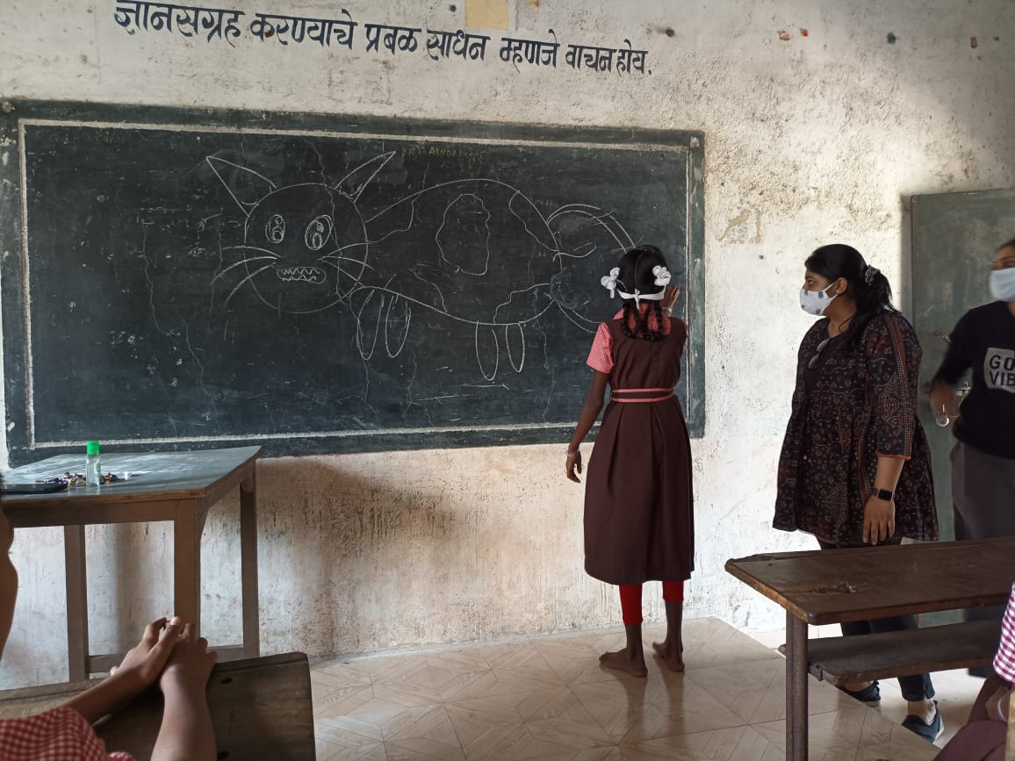

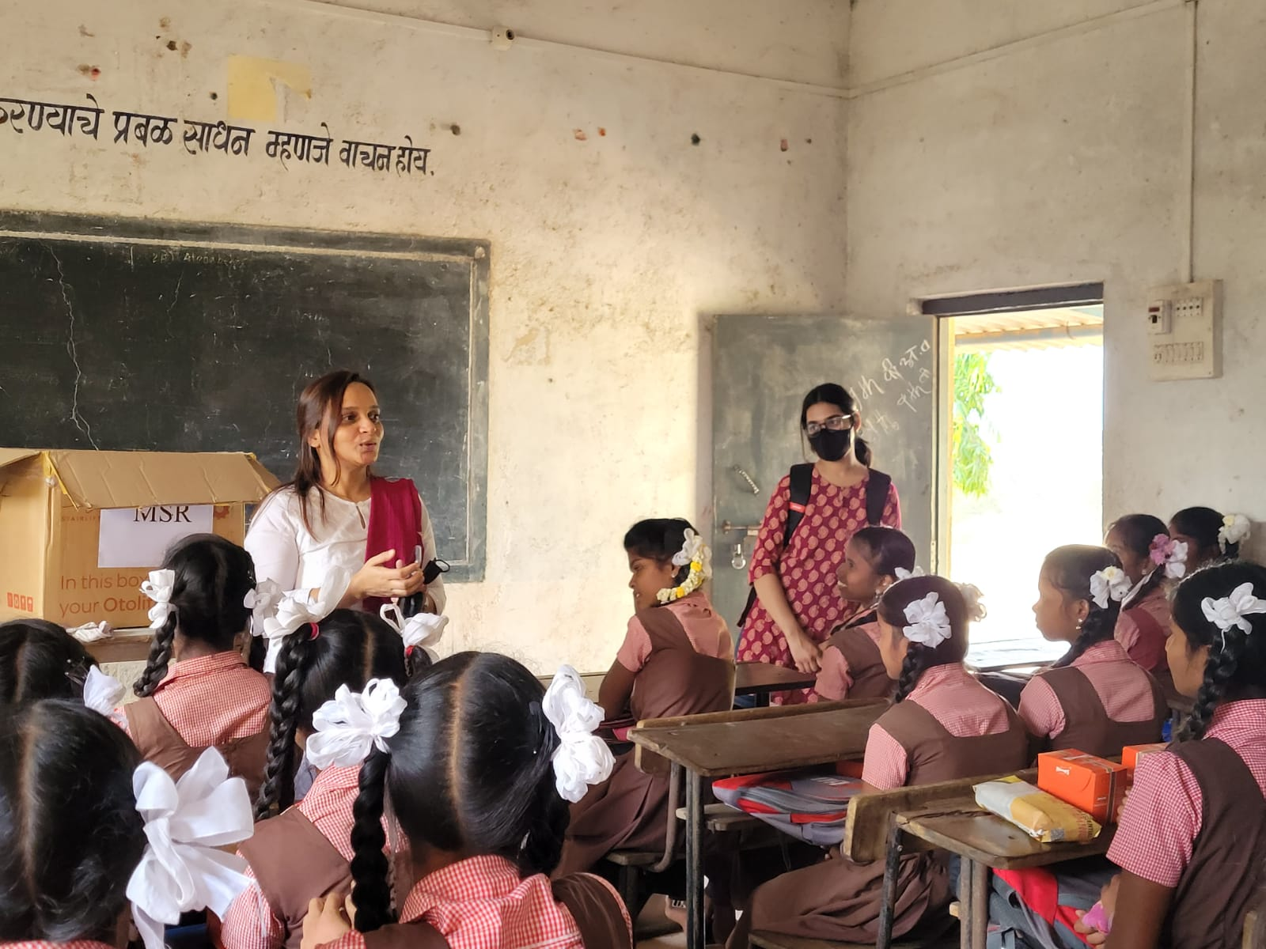

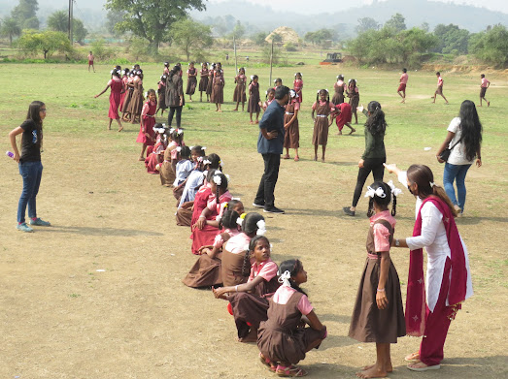

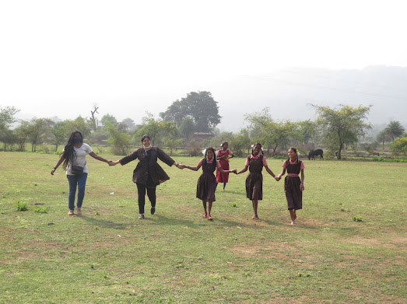

Interaction with Sarpanch Mrs. Manju Kombh 