Event Date: 27th June 2025
Time: 5:30 PM Onwards
Venue: The St. Regis Toronto – Louix Louis
City: Toronto, Canada
Overview
The N. L. Dalmia Institute of Management Studies and Research proudly hosted the Canada Alumni Chapter Meet in the vibrant city of Toronto. The event was a significant milestone in our global alumni engagement initiative and served as a warm celebration of shared memories, professional journeys, and enduring connections formed during the transformative years at NLDIMSR.
This elegant evening at Louix Louis, The St. Regis Toronto, offered panoramic views of the city skyline, perfectly setting the stage for an inspiring evening of reconnection, networking, and celebration.
Event Highlights
- A heartwarming welcome by alumni coordinators, setting a friendly and nostalgic tone for the evening.
- Sharing of individual journeys post-NLDIMSR, showcasing the impressive accomplishments and global footprints of our alumni in Canada.
- Insightful discussions on potential collaborations, mentorship opportunities, and ways alumni can continue contributing to the institute's growth.
- Presentation on recent institutional achievements and vision for the future by the Head – Alumni Relations, Ms. Geetanjali Sharma, which was met with applause and support.
- Cultural warmth, storytelling, and heartfelt memories filled the evening, culminating in a symbolic toast to the continued success of the alumni community across borders.
Photo Gallery
A group photo capturing the joyous gathering and spirit of the evening has been attached below:
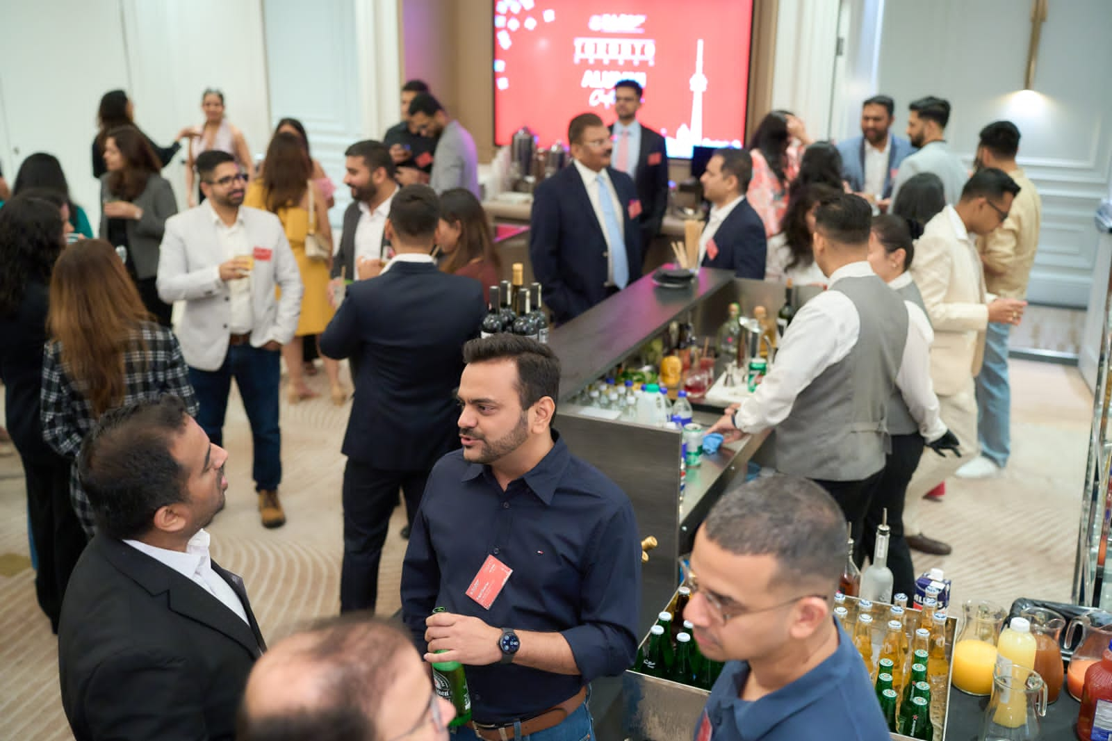
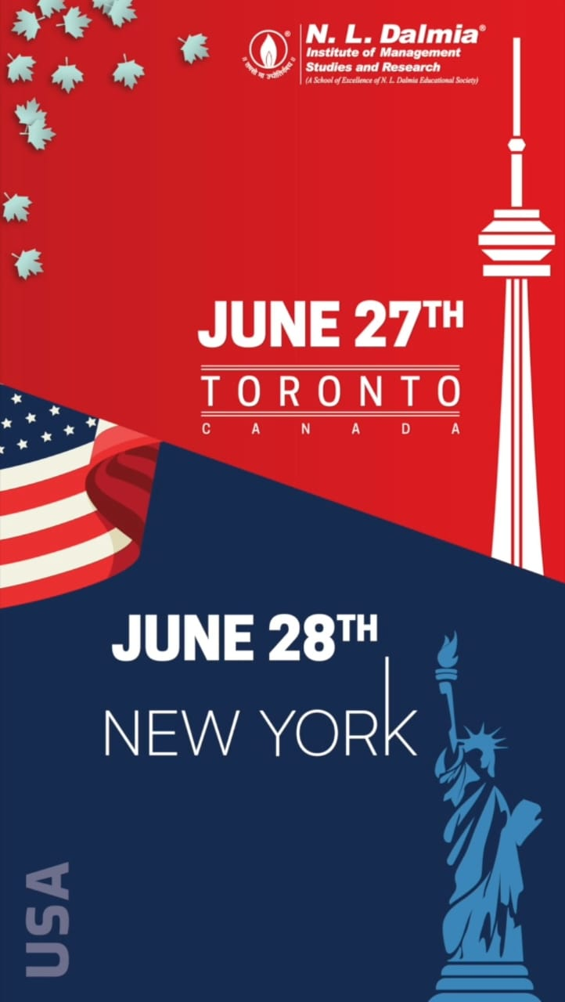

Attendance
Attached is the attendance sheet capturing the presence of all alumni attendees at the Toronto meet.

Canada Alumni Chapter Meet
Sr. No. | Name | Name of the organisation you are currently working | Designation | Course pursued at NLDIMSR | Year of Graduation | Year of Graduation (3 Years)
1 | Ani Sanjay Baranwal | Tim Hortons/ RBI | Supply Network Replenishment Analyst | MMS | 2014-2016
2 | Bhavin Desai | Ciel Fintech Inc. | Co Founder | MMS | 2002-2004
3 | Nisheth Pujari | Kinex Media | Business Development Manager | PGDBM | 2016-2018
4 | Pranav Haldiya | Trisura Guarantee Insurance Company | Senior Reinsurance Analyst | MMS | 2015-2017
5 | Ameya Gaikwad | Infrastructure Ontario | Portfolio Planning Manager | PGDBM | 2012-2014
6 | Pushkar Deole | Vertafore Canada | Product Owner | PGDM | 2016-2018
7 | Hardik Mehta | Royal Bank of Canada | Senior Relationship Manager | PGDBM | 2010-2012
8 | Ansh Nigam | Bank of Montreal | Manager - Lending Product ( Business Banking) | MMS | 2016-2018
9 | Kapil Sharma | BMO Financial Group | Senior Manager, Marketing Technology | MMS | 2011-2013
10 | Vaishnavi shetty | Sodastream Pepsi | Brand marketing | PGDM | 2019-2021
11 | Nikita Kaushik | YMCA GTA | Systems Manager | MMS | 2012-2014
12 | Saif Purkar | Lumi Rental Company | Head of Data | PGDBM | 2011-2013
13 | Sampada Inarkar | Teleperformance | Digital Account Manager at X | PGDM | 2019-2021
14 | Deepak Singh Rawat | Manulife | Investment Associate | MMS | 2016-2018
15 | FAISAL SHAIKH | BROADGRAIN COMMODITIES INC. | SENIOR ASSOCIATE | PGDBM | 2014-2016
16 | Somesh Negi | Scotiabank | Director | MMS | 2009-2011
17 | Isha Thakker | Dibbly Inc (on Mat leave) | HR Generalist | MHRDM |  | 2012-2015
18 | Nishita Mehta | ERNST & YOUNG | Manager | PGDM | 2013-2015
19 | Mitul Dharawat | Rockwallet | VP - Trading Operations | MMS | 2013-2015
20 | Saakaar Sharma | IMCO (Investment Management Corporation of Ontario) | Manager | MMS | 2013-2015
21 | Seema Mishra | Nestle | Revenue Manager | MMS | 2014-2016
22 | Nikita Nautiyal | TCS | Consultant | MMS | 2014-2016
23 | Anuj Thakar | ATCO structures | Regional sale representative | MMS | 2010-2012
24 | Neha Varyani | TD | Product Owner | MMS | 2011-2013
25 | Naman Banthia | Flinch | Founder and Business Owner | MMS | 2010-2012
26 | Samson Varel | Apex Group | Vice President Fund Services | PGDM | 2011-2013
27 | Ankit khandelwal | World Bank | Product Owner | MMS | 2010-2012
28 | Karishma bathija | BMO | Associate | PGDM | 2018-2020
29 | Rutuparn Ranadive | BMO | Compliance Officer | MMS | 2014-2016
30 | Om mehul joshi | I have completed my bachelors at nl Dalmia at 2023 BMS and rn doing masters | Student | PGDM | 2021-2023
31 | Rajpreet Kaur Bath | TD Securities | Vice President and Product Delivery Manager | PGDBM | 2012-2014
32 | Shail Thadeshwar | NA | NA | PGDM | 2020- 2022
33 | Kunal Jain | Citi | Vice President | MMS | 2011-2013
34 | Bhavishya Bhatt | POC limited | E-commerce Manager | MMM |  | 2016-2019
35 | Swapnil Sudhir Garge | Environics Analytics | Senior Account Manager | PGDM | 2012-2014
36 | Sukant Pabreja | Carlton One Engagement | Business Analyst | PGDM | 2015-2017
37 | Maithil Naik | Accenture | Inside Sales Associate | PGDM | 2020- 2022
38 | Nirmit Dave | BDO CANADA LLP | Senior Associate, Transaction Advisory services | GMBA | 2017-2019
39 | Jagmeet Kaur Pannu | Opulent Castle | CEO & Founder | MMM |  | 2018-2021
40 | Yatin Nayak | Ontario power generation inc | Work control team leader | MMS | 1997-1999
41 | Bhavik Jain | Sun Life | Client Services Representative | PGDBM | 2015-2017
42 | Smruti Mehta | TD Bank | Credit Manager-Business Banking | PGDBM | 2009-2011
43 | Kiran Mahavir Sharma | Bank of Montreal | Personal Banker | MMS | 2016-2018
44 | Tanvi Mishra | Riverside Natural Foods | Learning and Change Manager | PGDBM | 2009-2011
45 | Onkar Gokhale | Royal LePage Signature Realty | Realtor | PGDBM | 2011-2013
46 | Nikita Mehta | Oliver Marketing | Manager - Project Management | PGDM | 2010-2012
47 | Garima Sharma | SunLife Financial | Cloud Financial Analyst | MMS | 2014-2016
48 | Ashish Bheda | TD Bank | Market Risk | MMS | 2014-2016
49 | Sonia Ajit Prasad | Member of NABET 700- unifor ( Canadian film and television union) | Costume set supervisor ( dept of costumes) | PGDBM | 2011-2013
50 | Meghashree Nayak | NA studying | HR business Coordinator | PGDM | 2020- 2022
51 | Pravin Nayak | Aon Canada | Manager - Finance | MMM |  | 2010-2013
52 | Shivani Rajpuria | TD Bank Financial Group | Operations Analyst | PGDBM | 2014-2016
53 | Geetika Nautiyal | Tata Consultancy Services Canada Inc | Consultant | MMS | 2009-2011
54 | Vishal Aunchalia | Bank of Montreal (BMO) | Business Analyst | MMS | 2005-2007
55 | Abhijit Chawan | Carquest | Senior Finance Analyst | PGDBM | 2010-2012
56 | Himanshu Karande | Ontario Medical Oncology Association | Finance Manager | PGDBM | 2011-2013
57 | Prathik Poojary | WPP Media | Account Manager - Paid Media | PGDM | 2018-2020
58 | Yogesh | Scotia Bank | Senior Software Development Engineer Lead | MMS | 2002-2004
59 | Rishi Agrawal | CORE Investigations Inc | Director | PGDBM | 2002-2004
60 | Akanksha Katyan | IELTSwithAK ; School of Confidence | Founder | PGDBM | 2011-2013
61 | Zenia Achhadwala | Scotiabank | Sr. Manager - Commercial Credit Risk | PGDM | 2013-2015

Conclusion
The Toronto Chapter Meet was not just an event, but a reaffirmation of the strength, warmth, and pride that the NLDIMSR alumni community shares globally. The overwhelming participation, emotional connections, and enthusiastic discussions are testimony to the ever-growing legacy of our institution.
We look forward to many more such reunions, deeper engagements, and continued contributions from our global alumni family.
Together, we rise – across cities, continents, and careers.

