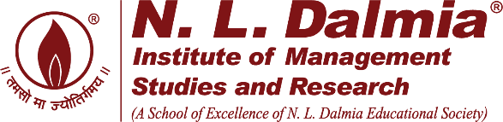


Decodex 2025
Report on Bamboo Art & Craft Display by MSR Committee
Date 14/02/2025
The N.L. Dalmia Institute of Management Studies and Research successfully hosted the 'Art & Craft Display by Kondgaon Bachat Ghat Ladies' as a key component of its annual flagship event DecodeX 2025 – A 24-Hour Hackathon Competition. This collaborative initiative was designed to showcase the traditional artistry and entrepreneurial capabilities of the Kondgaon self-help group.
The display, which featured a diverse range of handcrafted bamboo items, was met with enthusiastic participation and high praise. The event proved to be an exceptional success, not only in terms of visibility but also in achieving tangible economic results. Critically, the activity generated a substantial revenue of ₹14,000 for the Kondgaon Bachat Ghat Ladies, providing direct financial empowerment and validating their efforts.
The high quality and dedication evident in the work resonated strongly, earning significant appreciation, particularly from outstation participants and guests. Overall, the Kondgaon Art & Craft Display was highly instrumental in fostering community engagement, showcasing local talent, and upholding the institute's commitment to social responsibility.

