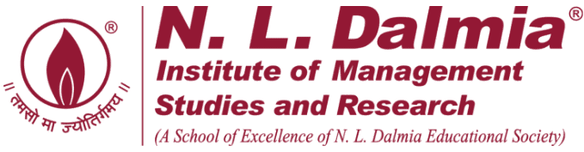
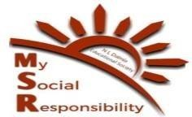
Kondgaon Visit
22/02/2025
NLDIMSR – MSR Committee organised a visit on 22/02/25 with the following objective:
- Distribution of 200 school bags to the students of 4 Zilla Parishad schools of Kondgaon.
- Conducted English and Maths class for primary students from 1st to 5th standard.
Team MSR interacted with the students, who shared their dreams and aspirations for higher education. The team also conducted English and Maths sessions, which helped the students engage better and learn new concepts.
Additionally, Team MSR visited the Panchayat Office, where women were undergoing training on sewing machines provided by the team last year. The training aimed to enhance their skills and create opportunities for economic empowerment. The women were also encouraged to design cloth bags with various prints and styles, which could be sold to vendors, providing them with financial support and sustainable livelihoods.
Team MSR is grateful for all the support and guidance provided by CEO Ma’am and the Faculty Members. We also thank Operations Team, Accounts Department, Marketing team, Administrative Staff, and the Support Staff for all the help in organising this visit.
The bags donated to the students were sponsored by the Accenture Company and ‘Together We Will’ NGO. We are thankful for their kind donation and also joining us for the visit.
The visit was co-ordinated under the guidance of Faculty-in-charge Dr. Nazia Ansari and planned, executed, and managed by Team MSR.

Pictures of the visit are below:

