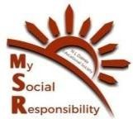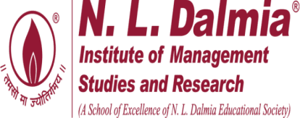

Kondgaon Visit 08/03/2025

Workshop on Menstrual Hygiene & Sustainability Campaign
On International Women’s Day, the MSR Committee of NLDIMSR visited Kondgaon on 8th March 2025 to promote menstrual hygiene awareness and women’s empowerment. The visit aimed to educate and support local women by providing them with essential hygiene products and guidance on sustainable menstrual practices. The visit had a participation of 130 women, making it an impactful and well-attended initiative.
A workshop on menstrual hygiene was conducted, focusing on the importance of maintaining cleanliness during menstruation and introducing women to reusable sanitary napkins as an eco-friendly and cost-effective alternative. The session included:
- Introduction to Menstrual Hygiene– Emphasizing the need for proper hygiene to prevent infections and health complications.
- Benefits of Reusable Sanitary Napkins– Explaining their affordability, sustainability, and skin-friendly nature.
- Step-by-Step Demonstration– Showcasing how to properly use, wash, dry, and store reusable sanitary napkins.
To support the adoption of sustainable menstrual hygiene practices, the following items were distributed among the attendees:
- 77 reusable sanitary napkins to encourage sustainable usage.
- 61 Soaps and 55 Dettol liquid bottles for personal hygiene.
- 70 Informational pamphlets detailing the correct usage, maintenance, and benefits of reusable sanitary napkins.
Team MSR sincerely appreciates the unwavering support and guidance of CEO Ma’am and the esteemed Faculty Members. We also extend our gratitude to the Operations Team, Accounts Department, Marketing Team, Administrative Staff, and Support Staff for their invaluable assistance in organizing this visit.

This initiative was successfully coordinated under the guidance of Faculty-in-charge Dr. Nazia Ansari and was meticulously planned, executed, and managed by Team MSR.
The Kondgaon visit on Women’s Day 2025 was a significant and impactful initiative, reinforcing the importance of menstrual hygiene education. By providing awareness, essential resources, and a platform for discussion, the visit aimed to empower women with the knowledge and tools needed for better menstrual health.

Pictures of the visit are below:

Workshop on Reusable Sanitary Napkins

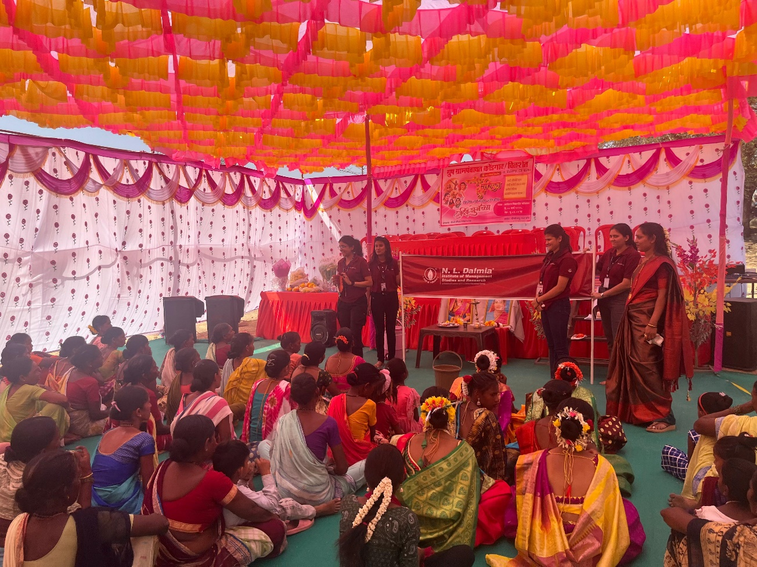

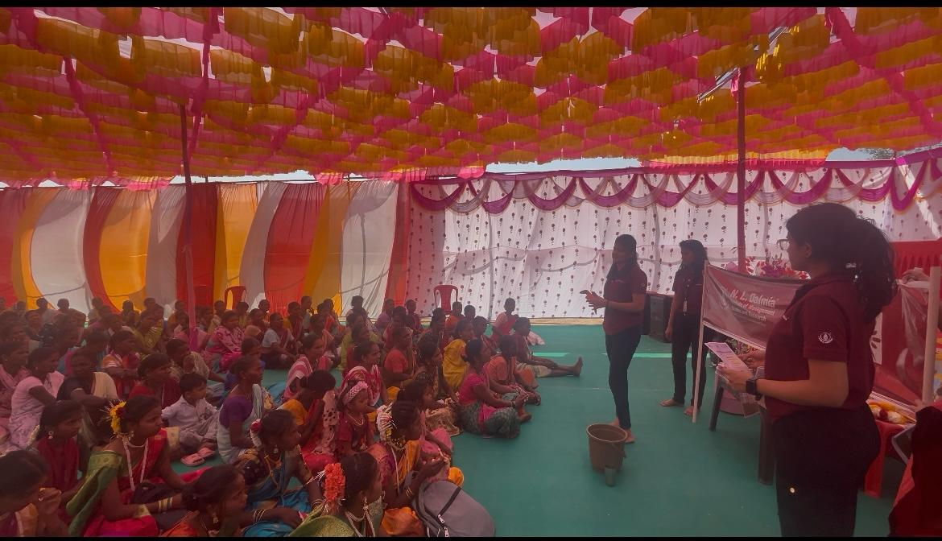

Distribution of Reusable Sanitary pads

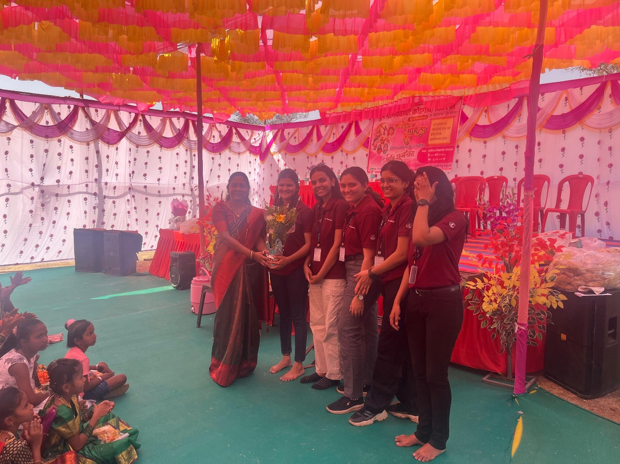
Felicitation by the Sarpanch of the village

