Kondgaon Visit
13/07/2023
On July 13th, 2023, MSR Committee organized a visit to Kondgaon Village, Palghar District. The objective of the visit was to interact with students and conduct interviews with teachers and students of Zila Parishad Schools and Shanti Ratan Vidya Mandir. Additionally, educational activities, including games and learning activities, were conducted during the visit. The aim was to provide an engaging and holistic educational experience for the students while gathering valuable insights for the accreditation process.

Mr. Sagar Rawool recorded the video of interaction between principal, teachers and students.
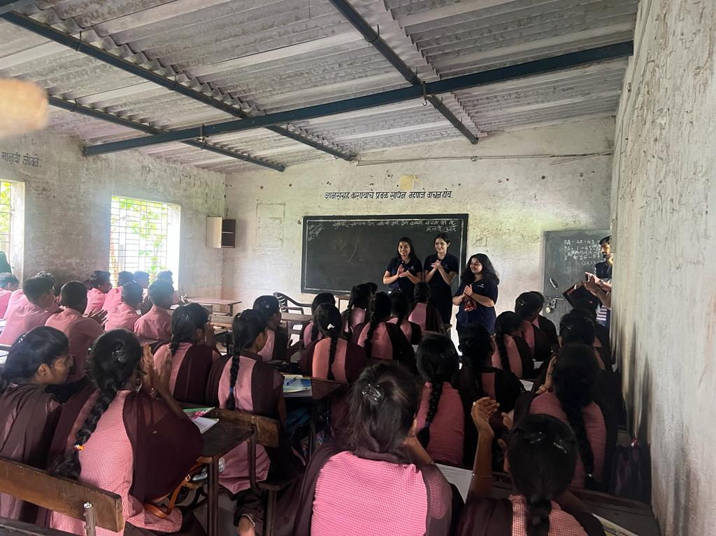
Mr. Dokle, Mr. Dayanand, Mr. Ashok & Ms. Priyanka played an instrumental role in making this visit successful by providing their insights regarding MSR-Committee work at Kondgaon village through interviews. The event was coordinated under the guidance of faculty-in-charge Dr. Nazia Ansari and planned, executed, and managed by Team MSR.
