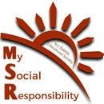
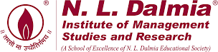
Rural Immersion Program
05/08/2023 & 19/08/2023

MSR committee organised Rural Immersion Program at Kondgaon for PGDM, Business Analytics and Global MBA batch 2023-25 as part of induction week on 05/08/2023 & 19/08/2023. The objective of this visit was to impart hands on experience of rural life to the fresher batch along with deep understanding of rural life, enabling them to embrace and integrate the invaluable lessons and experiences it offers into their own lives.

The following activities under verticals of - Education, Health and hygiene, Skill development and Environment were conduccted during the 2-day Rural Immersion program:

- Project Tiranga: Under this student of 6th grade were taught to make a tricolor craft article. Additionally, we provided insights into the symbolism behind each of the three colors and the significance of the Ashoka Chakra on the flag. Furthermore, we shared informative details about Independence Day.

- Mera Bharat Mahan: This activity was designed for the students studying in the class 7th. To make them aware about the country they live in, the students were provided with a political map of India. With the help of the students the children were being taught to locate the different states with their capitals situated in India on the map.
- Coloring and Math’s Activity: For this project, the Kondgaon students were given printed drawing sheets and math’s sheet and were directed by our juniors in coloring. Each of the students took a bunch of children, gave them guidance, and made a bond with them. Through this activity students tried to make the rural children exposed to creative aspects of learning, taught them name of colors in English and the pre-drawn sketch was showcasing the importance of Clean Environment.
- EVS Activity: The students were provided with the knowledge related to the different body parts in english. Students from the first year interacted with them and taught them the names of the different parts of a human body.
- School Bag and Stationery kit Distribution: We distributed 374 school bags in the schools inclusive of drawing books, set of six notebooks, pencil box, scale, crayons set, compass box, sponsored by Kotputli Kshetra Pravasi Sangh, KKPS Charitable Trust.
- Sanitary Napkin Distribution: A seminar was conducted by our Senior MSR members and juniors on Menstrual Hygiene. Also sanitary napkins were distributed to girls from grade 8th to 12th .
- Clay Activity: School students were given clay and with the help of our junior batch students they made various clay articles. This helped school students to majorly focus on improving their thinking ability and bring out their creative side.
- Dance and Outdoor Games: Our junior batch also indulged into various games like cricket, kho-kho, carrom, and dance activity with the kondgaon students. This fun session brought smiles on faces of all the children in the school.

We extend our special thanks to Prof. (Dr.) Seema Saini Ma’am for joining us on the visit and boosting our morale. We thank our Director Sir Prof. (Dr.) M. A. Khan for his constant support and guidance. We would also like to thank Dr Neeraj Gupta, Prof. Prakash Rathod, Prof. Minati, Prof. Jestin, Mr. Sagar, Mr. Vijay, and Mr. Krishant for joining and supporting Team MSR in all the activities. We also thank Mrs. Shamsree Sen Madam for sharing the surplus worksheets which were used in primary class educational activity.
We thank the Kondgaon Sarpanch, Mrs. Manju Kombh for her support and helping us with the lunch arrangements in coordination with the Kondgaon Mahila Bachat Ghat. We also thank all the principal and headmasters of Zilla Parishad Schools of Rawtalpada, Punjarpada, Gaothan, Goratpada, Gondpada and Dongripada for helping us in each and every activity.
We extend our thanks to the members of KKPS Charitable Trust for sponsoring the school bags and stationary kits for 374 kids and also joining us for the distribution camp.
We thank all the respected Faculties and Administrative staff for all the support and cooperation.

This event was coordinated under the guidance of Induction Program Faculty Coordinator Prof. Anand Dhutraj & MSR faculty-in-charge Dr. Nazia Ansari and planned, executed & managed by Team MSR.

Prof. (DR.) Seema Saini Mam interacting with students of Shanti Ratan Vidya Mandir

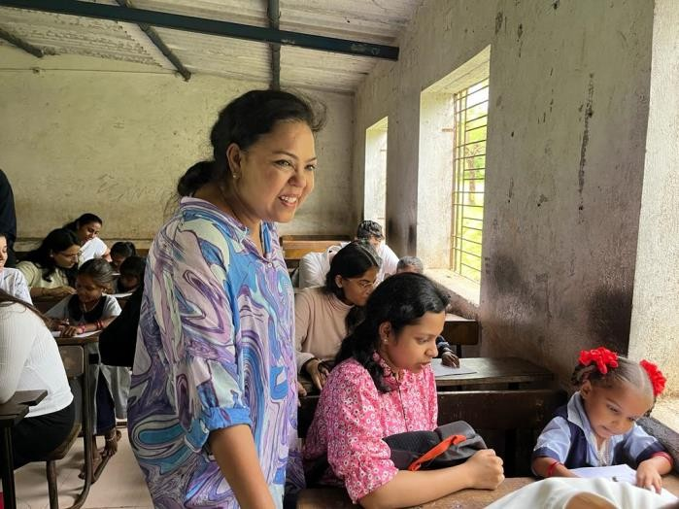

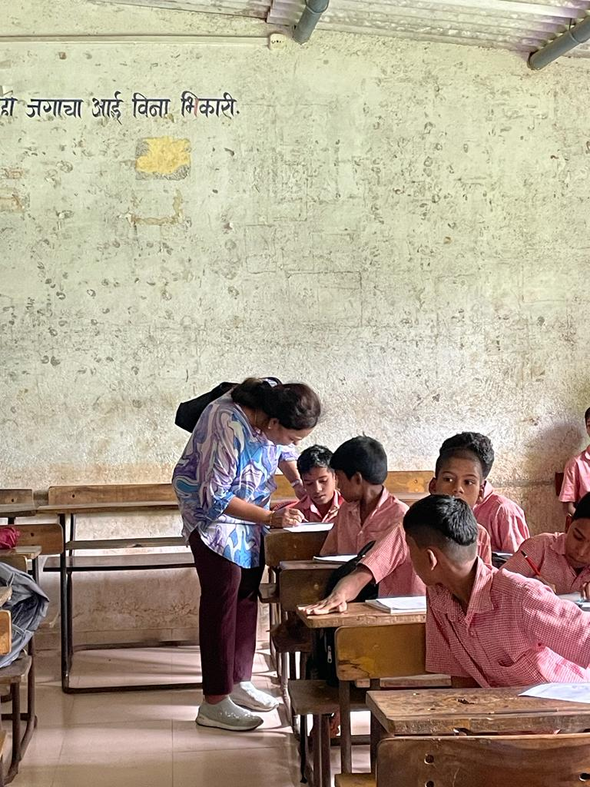

Independence Day Theme Activity: Mera Bharat Mahan

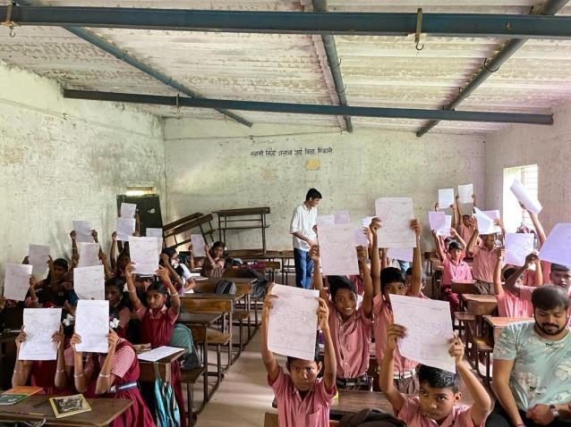
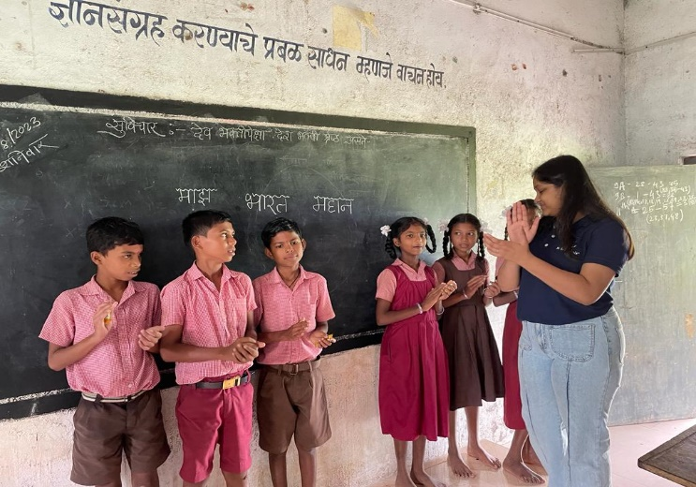

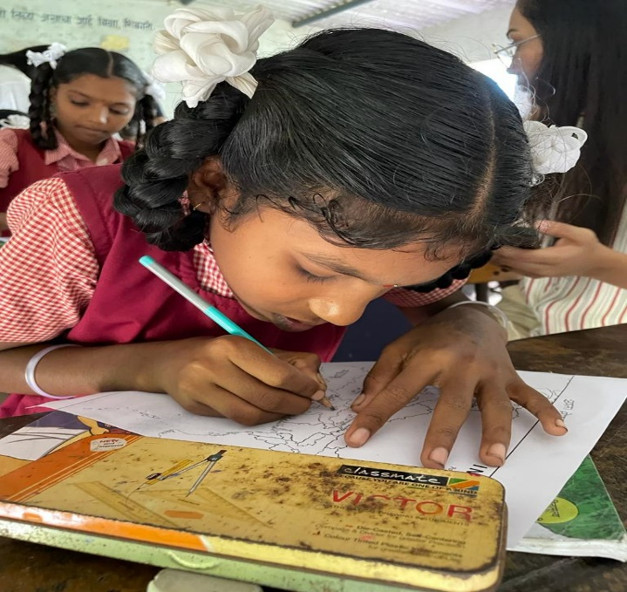
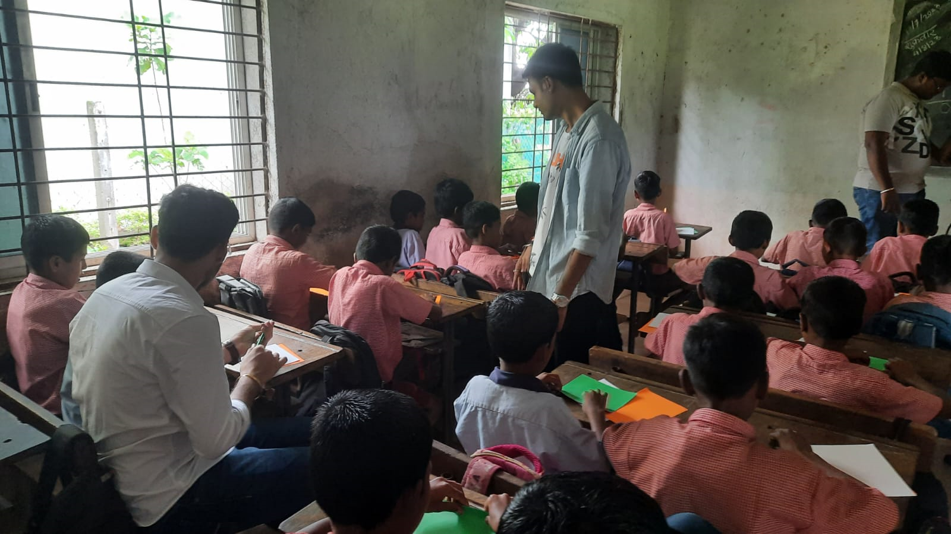

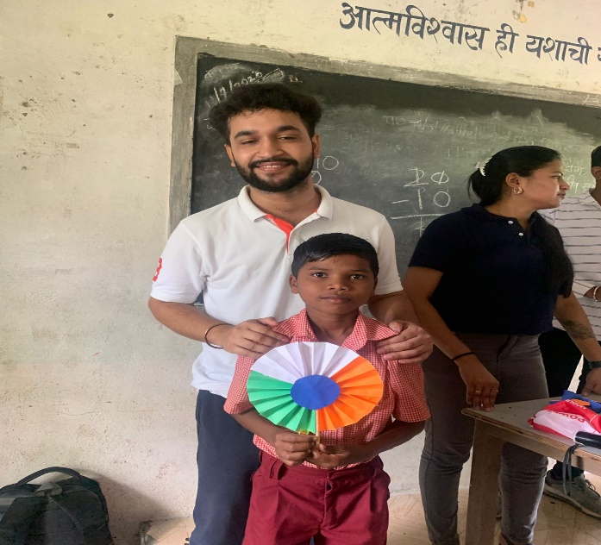

Primary Students’ Educational Activity

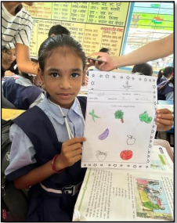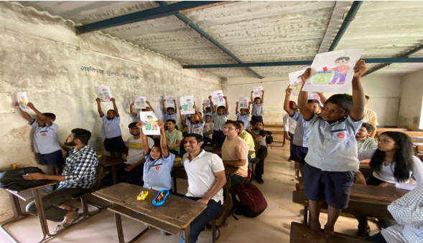

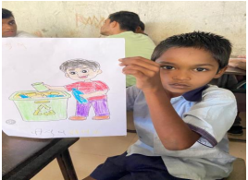
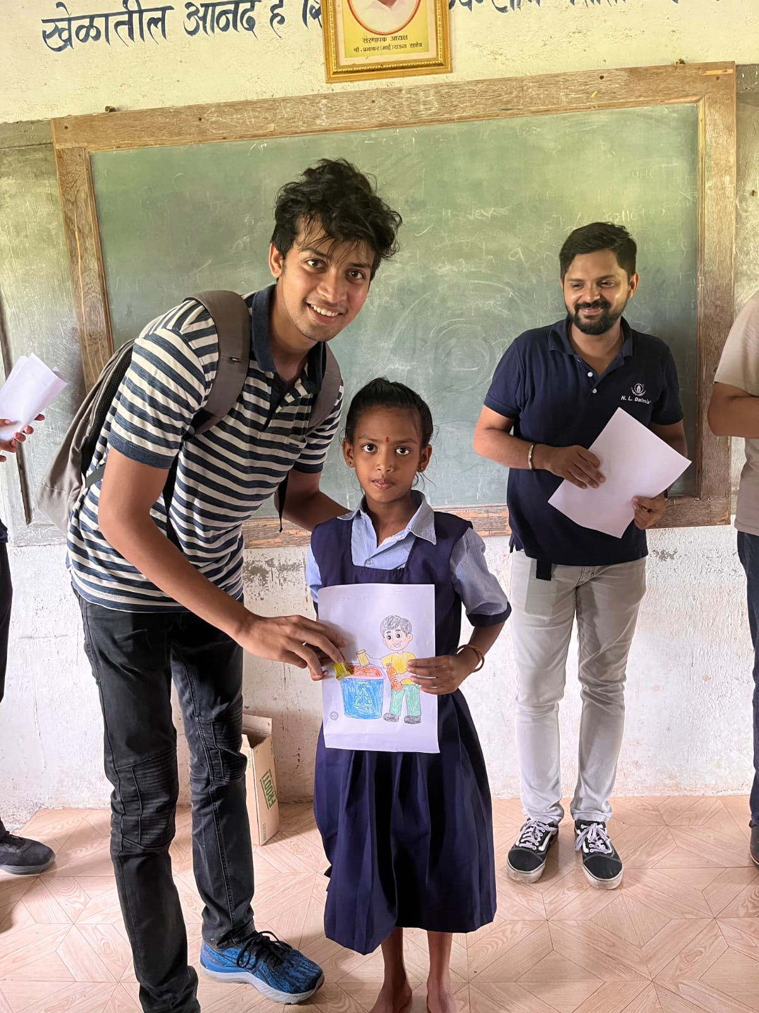

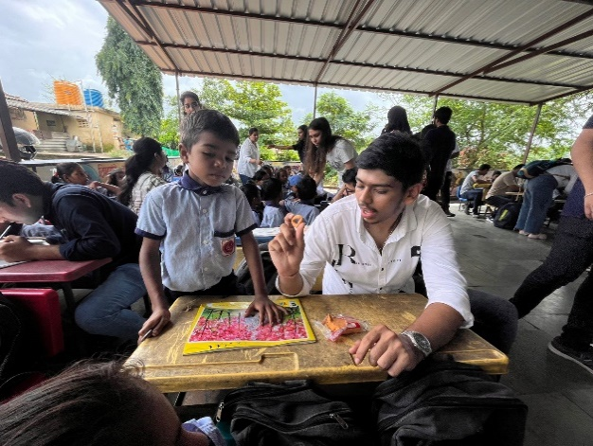

School Bag & Stationary Kit Distribution at 6 ZP Schools

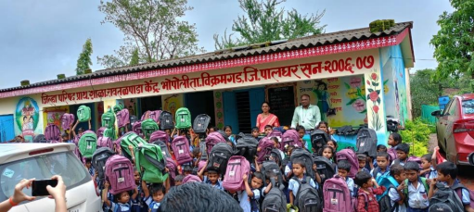

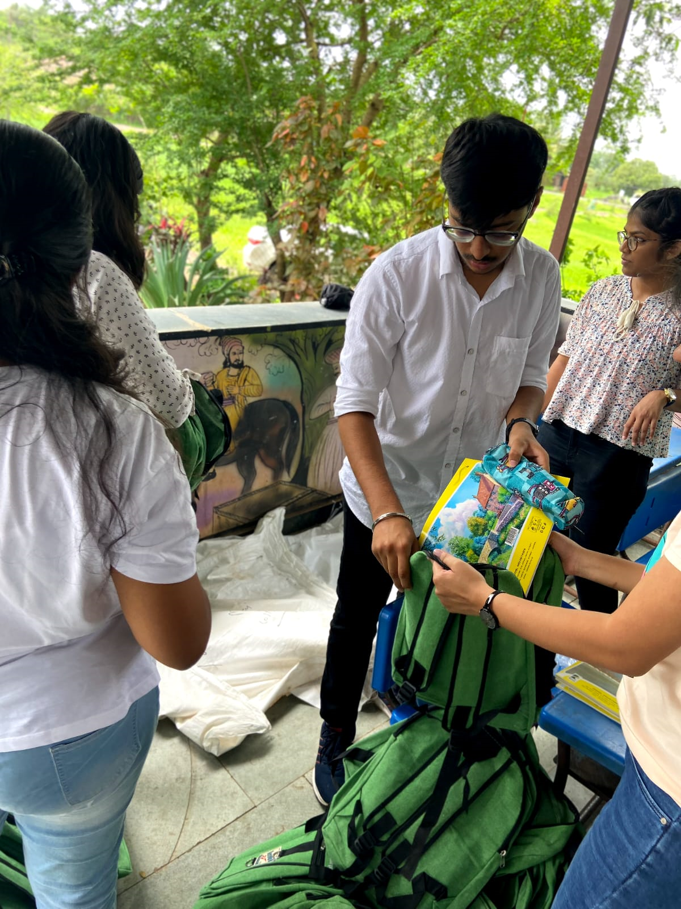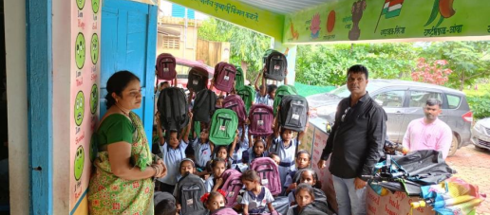

Sanitary Napkin Distribution & Menstrual Hygiene Awareness Camp

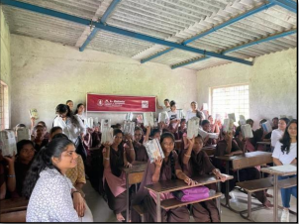

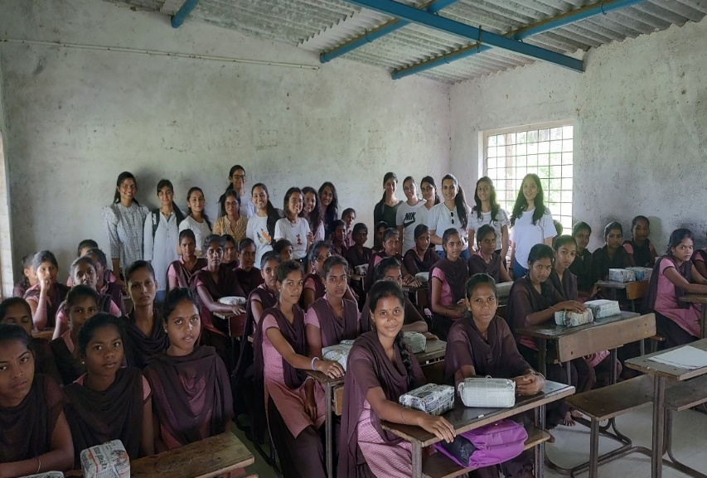

Fun with Clay

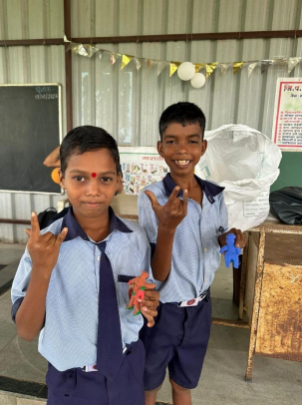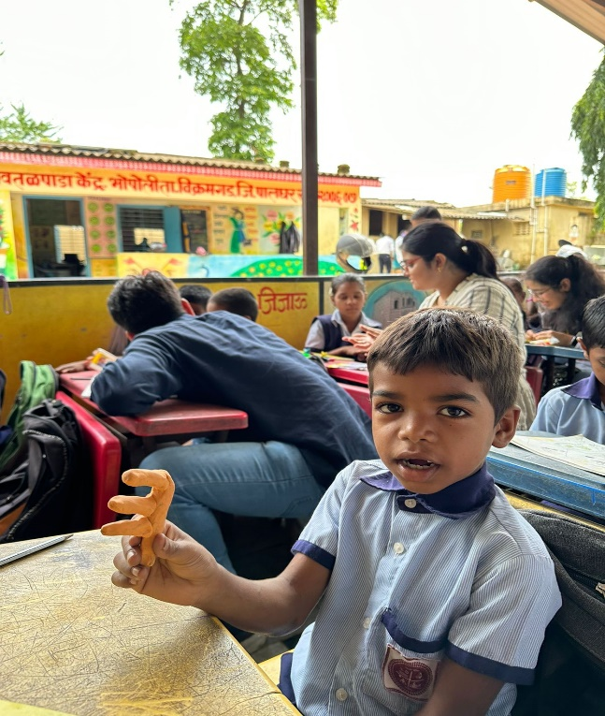

Indoor & Outdoor Sports

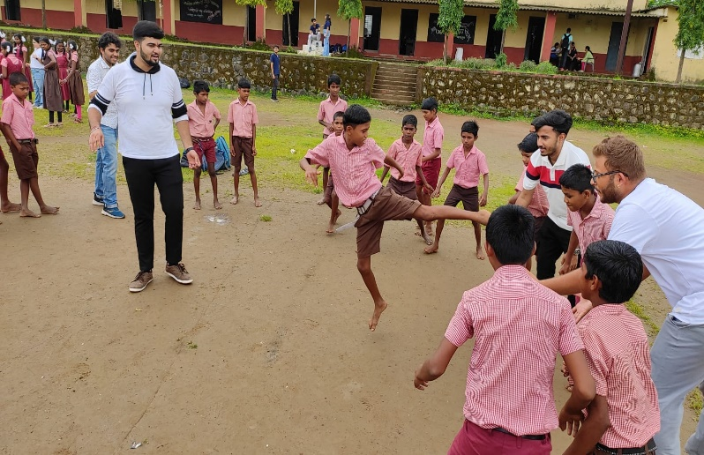
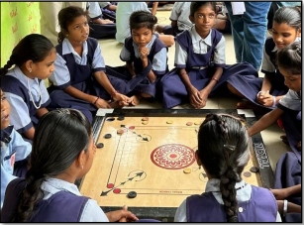

Batch 2023-25
