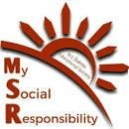

Rural Immersion Program

PGDM Batch 2024-26

19/07/2024

The rural immersion program at Kondgaon Village, organized by MSR committee of N. L. Dalmia Institute of Management Studies and Research (NLDIMSR), was a significant initiative aimed at fostering social responsibility among MBA students. The program, conducted on July 19, 2024, involved a series of educational and interactive activities with the village's school children. This report details the journey, activities, experiences, and reflections of the participants, highlighting the impact of the program on both the students and the village community.

The primary objective of the rural immersion program was to connect MBA students with underprivileged communities, providing them with an opportunity to contribute to social development. The program aimed to:
- Engage with the local school children and inspire them towards higher education.
- Provide the students with a practical understanding of rural life and its challenges.
- Encourage the development of leadership and empathy among the participants.
- Support the ongoing efforts of the MSR Committee in making Kondgaon a sustainable and self-sufficient village.

Journey to Kondgaon Village:
The journey to Kondgaon Village began early in the morning from the NLDIMSR campus. Around 180 students, along with faculty members and senior volunteers, boarded five air-conditioned buses equipped with breakfast provisions. The journey, which took approximately 4.5 hours, was filled with excitement as the students engaged in games, introductions, and interactions with their peers.

Arrival and Initial Impressions:
Upon arriving at Kondgaon, the participants were struck by the village's natural beauty. The contrast between the serene landscape and the challenges faced by the villagers was immediately apparent. The group was warmly welcomed by the village Sarpanch, Mrs. Manju Komb, and the principal of the local school. The hospitality extended by the village community set the tone for the day's activities.

Activities Conducted with the School Children:
The primary focus of the immersion program was the interaction with the school children of Kondgaon. The activities were designed to be both educational and entertaining, encouraging the children to engage actively with the volunteers. The day's activities included:

- Educational Sessions: The volunteers read chapters from the children's textbooks, recited poems, and helped clear doubts. The aim was to make learning enjoyable and accessible, especially for the younger students.
- Interactive Games: The volunteers organized games such as "Find the Odd Man Out," "Guess the Next Sequence," and simple puzzles. These activities were designed to enhance the children's cognitive skills while keeping them engaged.
- Art and Craft Activities: A session was dedicated to coloring and paper craft activities. The children, initially shy, gradually opened as they participated in these creative exercises. The use of chocolates and cookies as incentives helped break the ice and encouraged active participation.
- Dance Session: The volunteers and juniors conducted enjoyable dance. This session revealed the children's optimism and resilience, despite their challenging circumstances.
- Cultural Exchange: The day ended with a game of "Passing the Parcel," where the children had to perform a small task or recite a poem when the music stopped. This activity brought out the children's playful side and created a lively, joyous atmosphere.

The program helped the MBA students develop a deeper sense of empathy, leadership, and social responsibility. The experience of working with the children and understanding their struggles was a humbling and transformative experience for many.

We thank to Prof. (Dr.) Seema Saini Ma’am and Director Sir Prof. (Dr.) M. A. Khan for his constant support and guidance. We would also like to thank Dr Neeraj Gupta, Prof. Ritu, Prof. Minati, Prof. Jestin, Prof baliram for joining and supporting Team MSR in all the activities.

We thank the Kondgaon Sarpanch, Mrs. Manju Kombh for her support and helping us with the lunch arrangements in coordination with the Kondgaon Mahila Bachat Ghat. We also thank all the principal and headmasters of Zilla Parishad Schools of Rawtalpada, Punjarpada, Gaothan, Goratpada, Gondpada and Dongripada for helping us in each activity.

Glimpses of PGDM students interacting with Kondgaon villagers and children

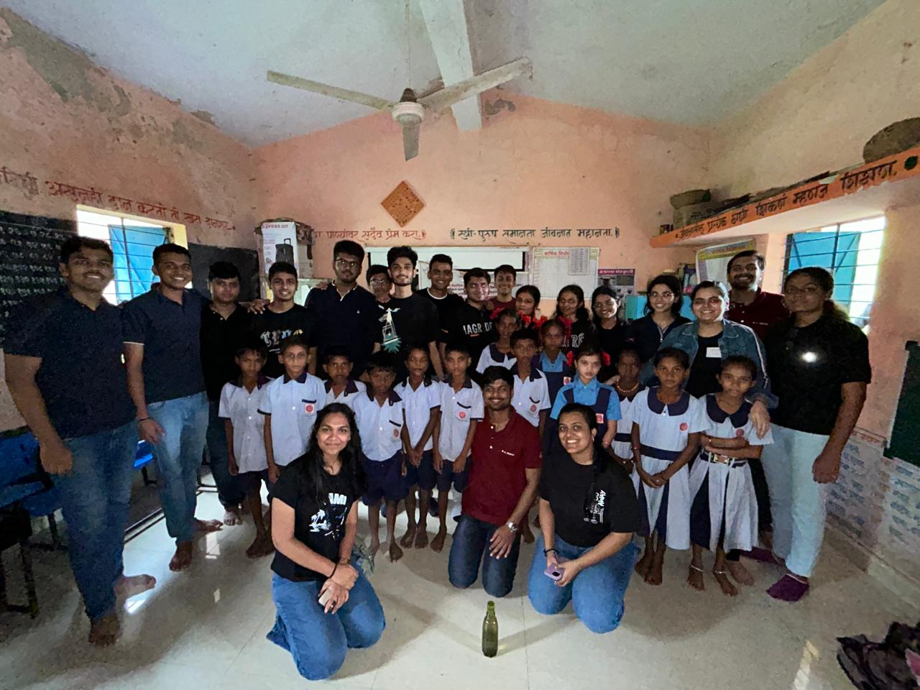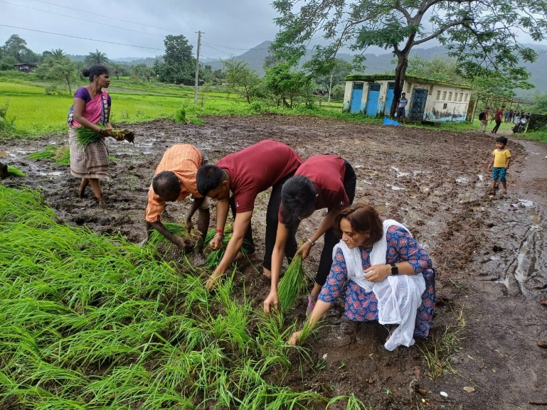

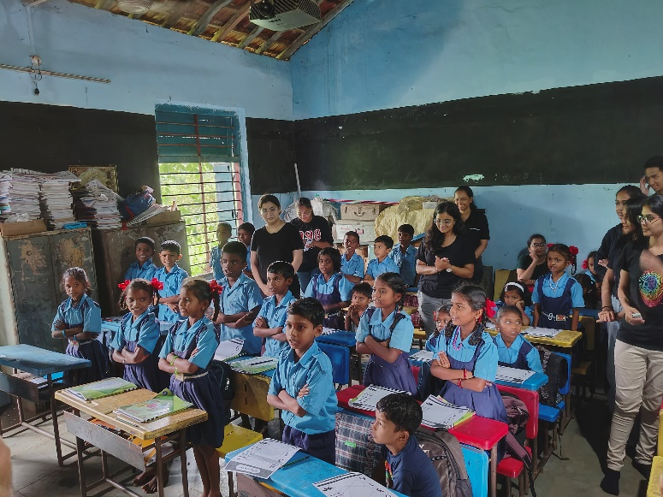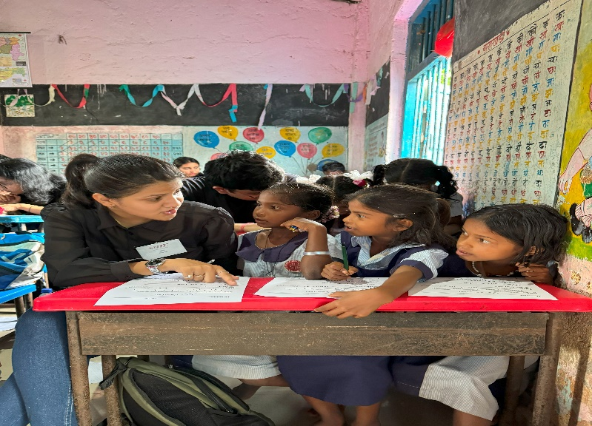

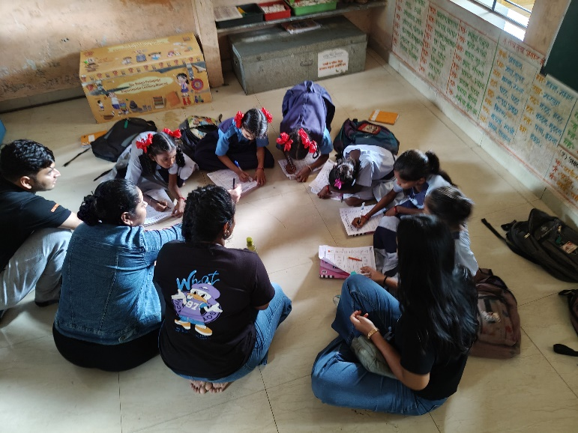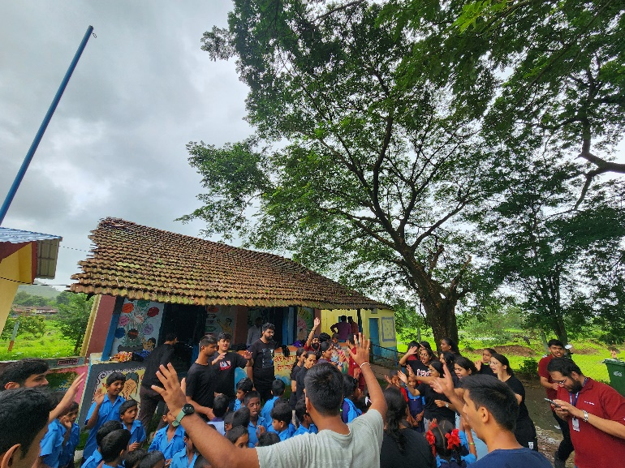

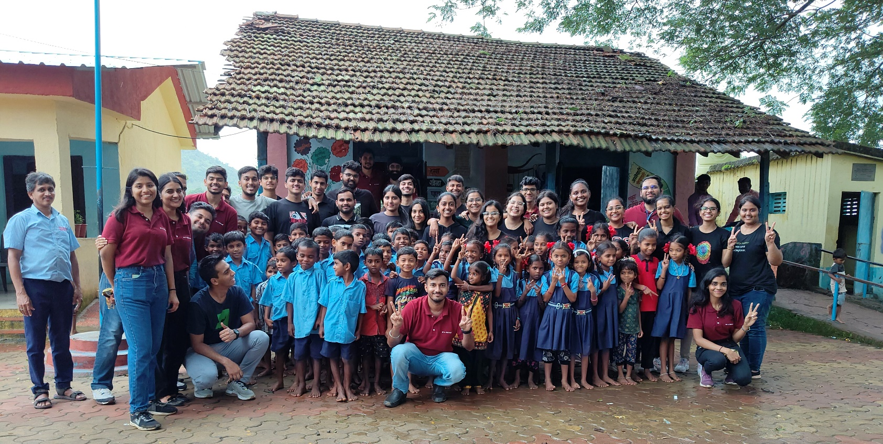

Batch 2024-26

