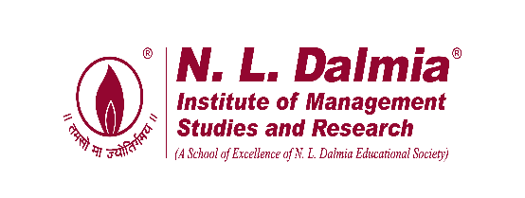
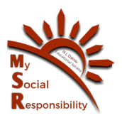
Kondgaon Visit with Rural Marketing Batch
03/09/2024

On September 3, 2024, the MSR Committee organised a visit to Kondgaon village in Palghar district for the Rural Marketing batch of 2023-25. The main objectives of this visit were as follows:
- To provide the rural marketing students with a hands-on experience of rural life and a deeper understanding of it.
- Distribution of Sanitary Napkins
- To gather data on additional requirements for the school and village, such as solar panels and well repairs.
During the visit, the Rural Marketing batch, along with MSR coordinators, engaged in various educational activities. They distributed approximately 600 sanitary napkins to 350 female students from classes 8 to 12, raising awareness about menstrual hygiene and proper disposal methods to protect the environment. Also snacks were distributed to 856 students of Kondgaon ZP school.
To gather information related to the aforementioned objectives, the MSR committee and rural marketing students visited the home of Mrs. Manju Kombh, the Sarpanch of Kondgaon village. She provided valuable insights into the feasibility of the objectives and shared information about Kondgaon Utsav.
Discussion were held related to Kondgaon Utsav that can be organised as per the availability of vegetables. Sarpanch provided information concerning products which could be sold by the villagers for the Kondgaon Utsav and when was it possible for the villagers to come to the Institute for the Kondgaon Utsav.
Team MSR is grateful for all the support and guidance provided by CEO Mam, Director Sir & Faculty Members. We also thank Operations Team, Accounts Department, Marketing Team, Administrative staff, and Support staff for all the help in organising this visit. We thank Prof. Jestin Johny, Prof. Ritu Tuli for joining us. Sincerest gratitude to the Rural Marketing students for being cooperative. The visit was coordinated under the guidance of Faculty-in-charge Dr. Nazia Ansari and planned, executed, & managed by Team MSR.
Pictures of the visit are as below:

Educational Activities
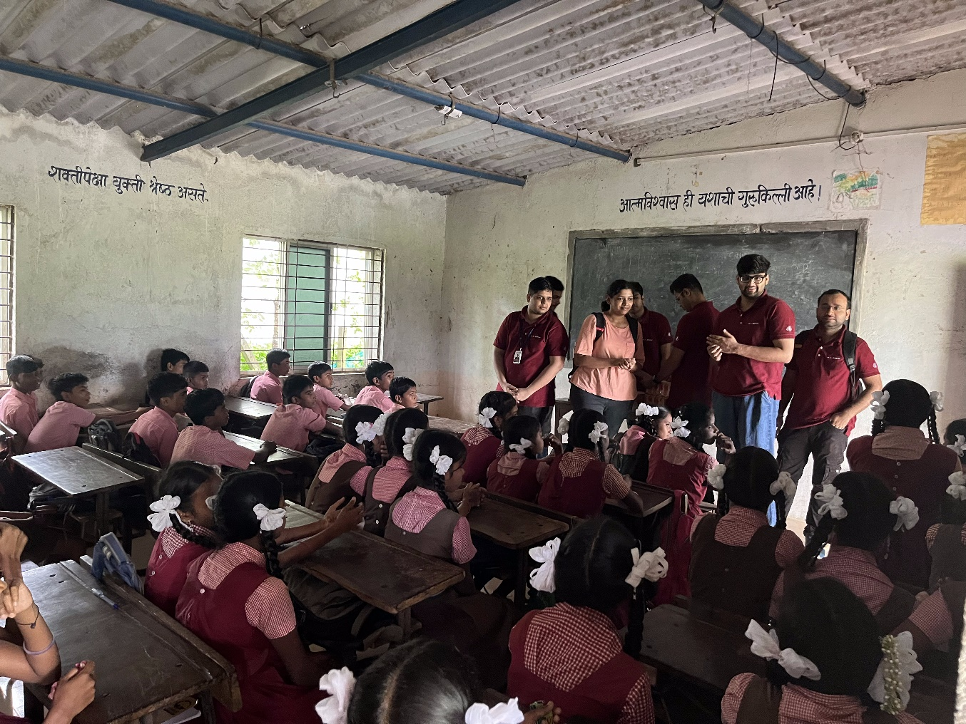

Snacks Distribution
