UAE Alumni Chapter Meet 2024 – Post-Event Report
We are delighted to share the success of the UAE Alumni Chapter Meet 2024, held on 15th November at The Taj Hotel, Burj Khalifa Street, Dubai. This first-of-its-kind alumni gathering in the region brought together over 65 senior alumni, marking an important milestone in NLDIMSR’s global outreach and alumni engagement efforts.
The evening was full of meaningful conversations, shared memories, and renewed connections, celebrating the collective pride of the NLDIMSR community.
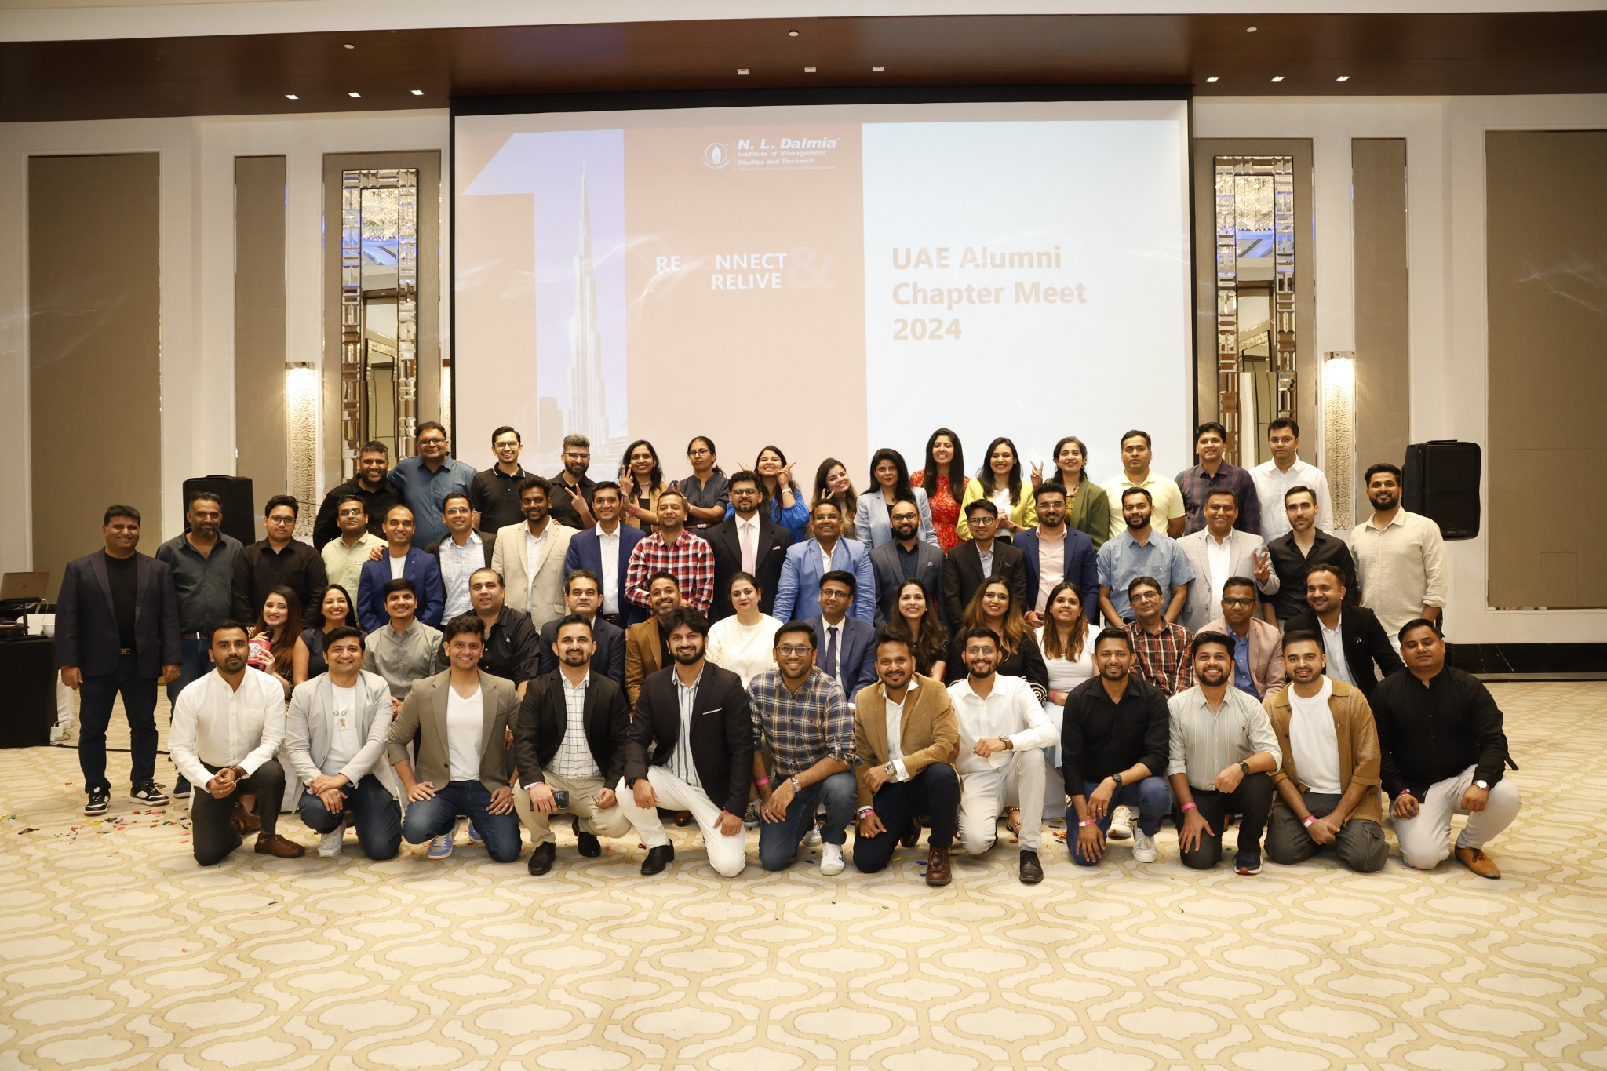
Glimpse from the evening

Highlights of the Evening
- • Welcome Note by Mr. Shailesh Dalmia, Hon. Secretary of NLDIMSR, who reflected on the Institute’s journey and global footprint.
- • Keynote Address by Mr. Mudit Dalmia, sharing the vision for alumni engagement and future collaborations.
- • Special Recognition of Mr. Shajid Merchant, the first student to enroll at NLDIMSR, honored for his pioneering legacy.
- • Presentation of “25 Years” Badges to our earliest alumni, commemorating their continued contribution to the Institute’s legacy.
- • Open Networking & Dinner, providing a vibrant space for professional and personal reconnections.

What Our Alumni Shared
“It was amazing to see how fellow alumni are doing so well personally and professionally. Hoping the community grows and shines!”
— Gaurav Kumar, MMS (2006–08)
“Too good an event. Very well organized. Glad to meet NLD alums. Look forward to many more.”
— Ritesh Mehta, MMS (2014–16)
“What an incredible journey it was during our golden days at NLD. Meeting batchmates and even seniors after many years was magical. Thank you to everyone who made this happen!”
— Rushabh Shah, PGDM (2010–13)

Attendee Glimpses
 | Organisation | Designation | Course (Batch)
  Name * | Email Id | Phone Number * | Name of the organisation you are currently working | Designation * | Course Pursued at NLDIMSR | Year of Graduation | Year of Graduation1
  Gaurav Kumar | Gaurav.seashore@gmail.com | 521172072 | TerraPay | Vice President | MMS | 2006-2008
  Gaurav Jain | gaurav.j@avendusspark.com | 91 9892372656 | Avendus Spark Capital | Director | MMS | 2006-2008
  Sarita Dubey | Saritadubey02@gmail.com | 9.72E+11 | Mashreq Bank | Director | MMS | 2007-2009
  Varun baheti | Bahetivarun@gmail.com | 9.72E+11 | FactSet UAE LLC | Analytics specialist | PGDM | 2014-2016
  Shahin Surti | shahinsurti@gmail.com | 9.72E+11 | Al Ghurair Properties | Senior VP - Portfolio Management | MMS | 2006-2008
  Jugal Shah | jugalshah18@gmail.com | 9.72E+11 | NielsenIQ | Manager | PGDM | 2014-2016
  Tony Thomas | tonysthomas@gmail.com | 9.72E+11 | Apparel Group | Manager Training | MHRDM |  | 2010-2013
  Samarth Shah | samarth_shah@live.com | 91990170611 | RAK Sovereign Fund | Deputy Manager | PGDM | 2015-2017
  Piyush Sawant | piyush.sawant92@gmail.com | +971 567892892 | RAKBANK | Lead Business Analyst - IT Projects | MMS | 2014-2016
  Alisha Pereira | alisha.apereira@gmail.com | 9.72E+11 | Gmg | Buyer | PGDM | 2013-2015
  Shivang | shivang_1986@hotmail.com | -586762435 | Deloitte Consulting | Engagement Manager | PGDM | 2010-2012
  Rohan Sawant | rohanmsawant@gmail.com | 554161017 | Kale Logistics solutions | General Manager - Products | MMS | 2006-2008
  Devendra Purohir | purohit_devendra@yahoo.com | 9.72E+11 | National Bank of Umm Al Qaiwain | Senior Relationship Manager | MMS | 2006-2008
  Anuj Garg | garg.anuj0504@gmail.com | 9.72E+11 | S&P Global | Associate Director | MMS | 2009-2011
  Sonali Kapadia Kothari | Sonalikapadia@gmail.com | +971 507672155 | Women First Jobs | Sr. Talent Acquisition Manager | PGDBM | 2009-2011
  Jayesh Jogi | jogijay08@gmail.com | +971 585300364 | BNP Paribas India Solutions pvt Ltd | Senior Associate | MFM |  | 2017-2020
  Gaurang Bhadesiya | gaurangyds@gmail.com | 9.72E+11 | Lazulite Technology Services LLC | Accounts Manager | MFM |  | 2017-2020
  Ayushvardhan Goyal | goyal_ayushvardhan@yahoo.co.in | 9.72E+11 | Nissan Middle East FZE | Deputy General Manager - CRM & Innovation | PGDM | 2009-2011
  Ritesh Mehta | Ritmehta82@gmail.com | 9.72E+11 | ARDENT ADVISORY AND ACCOUNTING | Director | PGDBM | 2001-2003
  Jay Rathod | jay.rathod1@gmail.com | +971 561147924 | Apropos General Trading LLC | Senior Accountant | MFM |  | 2018-2021
  Jaikishan Taurani | Jaikishantaurani@gmail.com | +971 561748580 | Factset UAE LLC | Senior Strategic Consultant | MMS | 2013-2015
  Kapil Jagtap | kapil.sj13@gmail.com | +971 562743787 | Unilever | CMI Head - Arabia | PGDM | 2010-2012
  Vikram Sawant | Vikram.sawant2007@gmail.com | 9.72E+11 | Landmark group | Senior Planning Manager | MMS | 2010-2012
  Ketan Jagtap | 13.ketan@gmail.com | 9.72E+11 | Emirates NBD | Portfolio Manager | PGDBM | 2009-2011
  Akhil Rai | Akhil3000@gmail.com | 505579874 | HABIB INVESTMENTS LIMITED, DIFC | DIRECTOR - PRIVATE BANKING | MMS | 2002-2004
  Tripti Chapper | mycareerhorizons@gmail.com | 523089792 | Career Horizons | Founder & CEO | MFM |  | 2003-2006
  Lalith Kishore | kishore.lalith@gmail.com | 9.72E+11 | Blueocean IT Solutions | Director | PGDBM | 2006-2008
  Kamlesh Parmar | Parmarkamlesh2008@gmail.com | +971 50 4599607 | Cotecna Inspection SA | Area Director | MMM |  | 2010-2013
  Karthik Muthusubramanian | m.s.karthik87@gmail.com | 9.72E+11 | Abudhabi commercial bank | Senior manager | PGDBM | 2007-2009
  Nimisha Ajmera | nimi.ajmera@gmail.com | 9.72E+11 | CitiBank | Senior Vice President - Credit Risk Portfolio Manager | PGDBM | 2007-2009
  Kapil Golechha | Kapilgolecha@rediffmail.com | 558117358 | Majid Al Futtaim Trust | Vice President | PGDBM | 2003-2005
  Anisha | anishamakani@gmail.com | 555366010 | ADCB | Executive Manager | PGDBM | 2005-2007
  Shirish Garodia | Garodia_shirish@yahoo.com | 9.72E+11 | Tata International Limited | Head of Treasury, AFCL | MMS | 2006-2008
  Pratyush Verma | pratyush_verma@hotmail.com | 9.72E+11 | Business , independant investments | director | PGDBM | 2005-2007
  Anurag Mishra | anuvmishra@gmail.com | 9.72E+11 | BlueOcean IT Solutions | Executive Director | MMS | 2006-2008
  Rajat Mathur | mathurrajathoney@gmail.com | +971 50 148 8645 | LiteTech Industries | Area Manager | PGDBM | 2007-2009
  Franklin Rebeiro | Franklinrebeiro@gmail.com | 565915534 | Redington Middle East Llc | Sr. Credit Executive | MMS | 2012-2014
  Sonia Thakkar Patel | soniabpatel24@gmail.com | 9.72E+11 | Na | Na | PGDBM | 2006-2008
  Mahesh N Shinde | mns2410@gmail.com | 968 - 95201836 | Sohar International Bank - Muscat, Oman | AVP, Senior Relation Manager - Corporate Bankong | PGDM | 2010-2012
  Divesh Israni | Divesh.israni@gmail.com | 505525404 | Kantar worldpanel | Retail and shopper Director | MMS | 2005-2007
  Jyothi Iyer | Jyothi.iyer@gmail.com | 9.72E+11 | Self Employed | Leadership and Career Coach | MMS | 1999-2001
  Shailesh Jain | Shailesh.jain86@gmail.com | 9.72E+11 | Al Boom marine | Head of planning and merchandising | PGDBM | 2009-2011
  Robin Varghed | Robin.varghese06@gmail.com | 521464894 | Protiviti Management consultancy | Associate Director | MMS | 2012-2014
  Shreya Menon | Menonshreya28@gmail.com | 524877005 | Gulf Marketing Group | Senior Consultant | PGDBM | 2012-2014
  Meghavi Solanki | Meghavisolanki22@gmail.com | 525749601 | Himalaya Wellness | HRBP ASSOCIATE | PGDM | 2019-2021
  Vikas Sharma | vikassharma1392@gmail.com | 508823705 | Efficio Consulting MENA | Senior Consultant | MMS | 2014-2016
  Mehul Rathod | Mehul@foode.club | 9.19E+11 | Foode | Partner | MMS | 2009-2011
  SHAJID MERCHANT | shajidmerchant@gmail.com | 9819641716 | Eastwood Schools | IBDP Coach and College Counselor | MMS | 1997-1999
  Rohit Mali | rohitm1607@gmail.com | +971 58 932 8308 | Aditya Birla Global Trading | Manager | PGDBM | 2011-2013
  Sean Rodrigues | Sean.d.rodrigues@gmail.com | +91 9664228259 | Ambit Capital Pvt Ltd | Manager | PGDM | 2017-2019
  Aditi Sawant | Aditibdsawant@gmail.com | +91 9930593362 | Tata Cliq Palette | Revenue Growth Manager | PGDM | 2017-2019
  Niharika Pandey | Niharika2408@gmail.com | 9.72E+11 | Al Tayer Insignia LLC | Finance Executive | MMS | 2012-2014
  Sandeep agarwal | agarwal.sandeep79@gmail.com | 9.72E+11 | HSBC bank | Manager | MMS | 2002-2004
  Pragya Tak Singh | Pragyasingh1980@gmail.com | 9.72E+11 | United Arab Bank | Manager - Trade and Supply Chain Finance | PGDM | 2002-2004
  Ajeet kumar | Ajeet.k2205@gmail.com | 9.72E+11 | Abu Dhabi commercial bank | Executive manager: private banking | PGDBM | 2002-2004
  Suraj Sharma | sharmasuraj0709@gmail.com | -505280490 | Valency International DMCC | Trader | MMS | 2013-2015
  Siddharth Sonik | siddharthsonik@gmail.com | 9.72E+11 | NielsenIQ | Director | PGDBM | 2010-2012
  Masoom Shah | masoomsshah@gmail.com | 9.72E+11 | Majid Al Futtaim | Planning Manager | MMS | 2012-2014
  Manas Bhatt | bhattmanas@gmail.com | 9.72E+11 | Commercial Bank International | Senior Vice President | PGDM | 2002-2004
  Heena Pathan | heenahpathan@yahoo.in | 528635773 | GMG | Planner | PGDBM | 2012-2014
  Rushabh Shah | rushabhshah1981@yahoo.com | 589273731 | Al Moosa group | CFO | MMS | 2003-2005
  Jaydeep D Hinger | Jaydeep.hinger@gmail.com | 9819657120 | JD Jewels | Proprietor | MMS | 2016-2018
  Dhananjay Uplekar | dsuplekar@yahoo.co.in | 566833487 | Emirates Investment Bank | Head of Treasury | MMS | 2002-2004
  Shoaib Shaikh | toshoaibhussain@gmail.com | 7387747799 | Trent Ltd | Assistant Merchandising Manager | PGDM | 2020- 2022
  Saif Jagirdar | saifjagirdar93@gmail.com | 9.72E+11 | Alpha System's | Partner | MMS | 2015-2017
  Liyanka Mandal | liyanka92@gmail.com | +971 589673457 | Amsha Advisory | Head of HR | MHRDM |  | 2016-2019
  Saurabh Mehta | Saurabh.mehta927@gmail.com | 9.72E+11 | Napptix | Co-founder | PGDBM | 2008-2010
  Marc Mendonca | marcmendonca06@mrfc.com | 7738575547 | BNP Paribas | Senior Associate | PGDM | 2022-2024

Moving Forward
The success of the UAE Alumni Chapter Meet encourages us to continue nurturing the global NLDIMSR family. Plans are already underway for the upcoming Europe Chapter Meet 2025 in London.
We invite alumni across the globe to stay engaged, lead regional chapters, and contribute toward a vibrant, connected alumni network.
For queries, suggestions, or to volunteer, write to us at:
alumni@nldalmia.edu.in

