N. L. Dalmia Institute of Management and Research
USA Alumni Chapter Meet 2025
Venue: The New York Hilton Midtown, New York City, USA
Date: Saturday, 28th June 2025
Time: 5:30 PM onwards

Event Report
The N. L. Dalmia Institute of Management and Research proudly organized the USA Alumni Chapter Meet 2025 at the prestigious New York Hilton Midtown, located in the heart of Manhattan. This landmark event brought together accomplished alumni from diverse batches and professional domains, who are now making significant contributions in leadership roles across global organizations.
The event was an extraordinary celebration of connections, memories, and institutional pride. Alumni from various cohorts came together to share their journeys, exchange ideas, and reminisce about their formative years at the Institute. The evening also provided a vital platform for strengthening the bond between the Institute and its thriving global alumni community.
This gathering not only reinforced the spirit of unity and lifelong engagement among alumni but also served as a testament to the Institute’s enduring commitment to fostering a global network of successful professionals.

Group Photograph

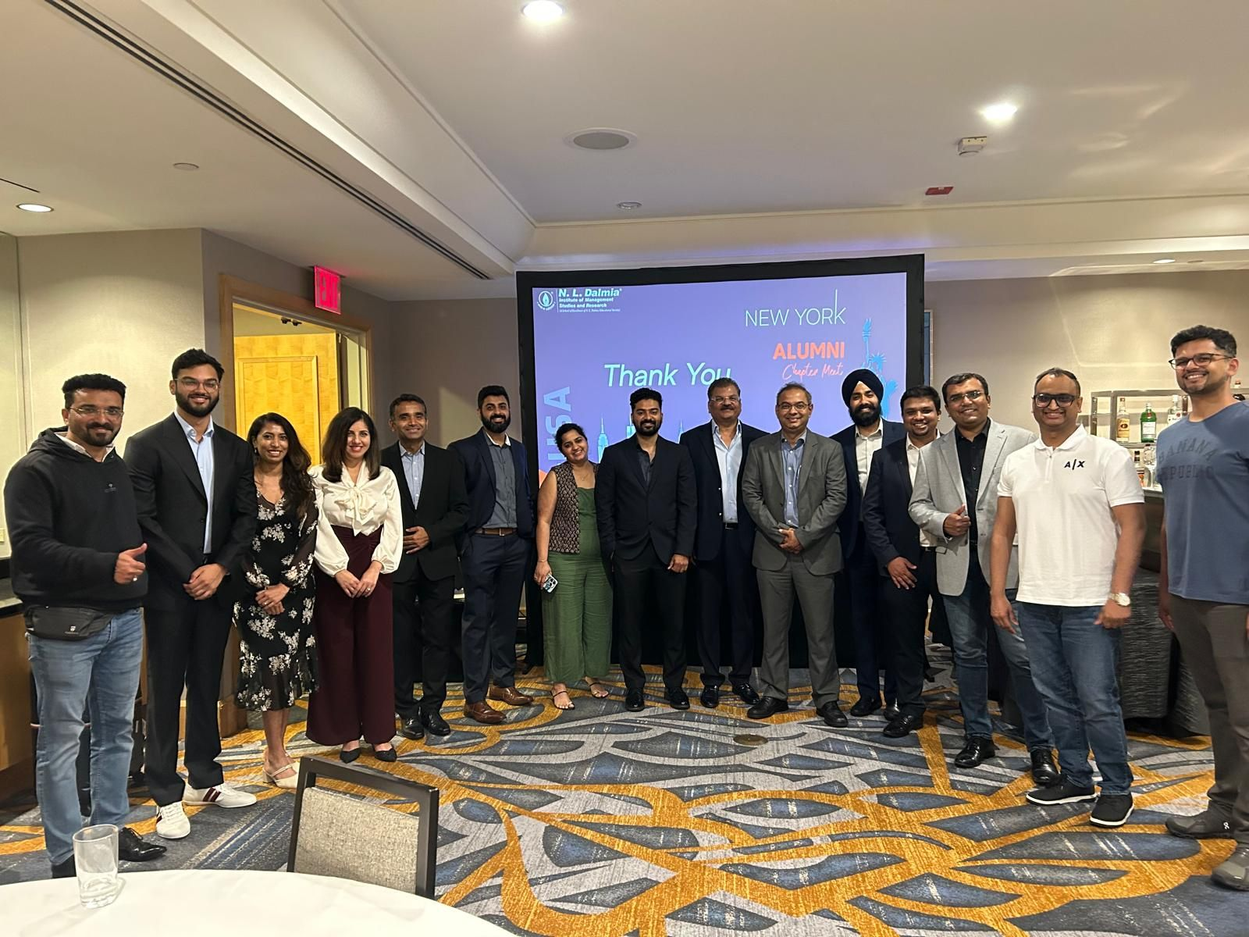
The group photograph captured during the event stands as a symbolic reminder of the strength and solidarity of the NLDIMSR alumni network. It encapsulates the essence of the evening — a gathering of trailblazers, united by a shared legacy.

Key Highlights of the Evening
- Welcome Note: The evening commenced with a warm and gracious welcome extended by the organizing team, setting the tone for an engaging and heartfelt event.
- Institute Update: A comprehensive presentation was delivered, highlighting key developments at the Institute, including recent academic achievements, international collaborations, new infrastructural milestones, updated accreditations, and the Institute’s future vision.
- Alumni Reflections: Selected alumni were invited to share their personal and professional journeys post-graduation. Their stories served as inspiring narratives of growth, perseverance, and success, reinforcing the impact of the Institute’s academic foundation.
- Networking Mixer: A dedicated networking session allowed alumni to engage with fellow professionals from diverse industries and backgrounds. This segment witnessed enthusiastic participation and the exchange of business ideas, referrals, and collaborative opportunities.
- Interactive Dialogue: A brief open forum allowed alumni to share suggestions on how to strengthen alumni engagement, contribute to the growth of the alumni association, and mentor the current student body.
- Vote of Thanks: The evening concluded with heartfelt gratitude expressed to all attendees for their active involvement, continued support, and unwavering connection to their alma mater. The note emphasized the importance of sustaining these interactions and outlined future plans for regional alumni meets and collaborative initiatives.

USA Alumni Chapter Meet
Sr. No. | Name | Name of the organisation you are currently working | Designation | Course pursued at NLDIMSR | Year of Graduation | Year of Graduation (3 Years)
1 | Aakash Sharma | Broadridge Financial Solutions | Business Analyst | GMBA | 2018-2020
2 | Aditi Joshi | American express | Senior Manager | PGDBM | 2011-2013
3 | Akshata karmalkar | Jp morgan | Vice president | MFM |  | 2005-2008
4 | Apoorva Shah | Tata Consultancy Services | Marketing Head - North America | PGDM | 2008-2010
5 | Atharva Vaidya | Truist | Analytics Specialist | PGDBM | 2015-2017
6 | Chirag Shah | BMS | Senior Manager | MFM |  | 2011-2014
7 | Devesh Bhagat | Morgan Stanley | AVP - Commodities Transformation | PGDBM | 2010-2012
8 | Harshad Phadke | B | PM | MMS | 1999-2001
9 | Jasvinder Singh Saini | Deutsche Bank | Vice President | PGDBM | 2004-2006
10 | Jeet Advani | Enfusion | Product Manager | MHRDM |  | 2007-2010
11 | Mehul Jobanputra | Citigroup | Sr VP | PGDBM | 2007-2009
12 | Neha Chadha | Amazon | Sr. Product Manager Tech | MMS | 2010-2012
13 | Neha Chadha | Amazon | Senior Product Manager Technical | MMS | 2010-2012
14 | Nishant Mahitcha | Wells Fargo | Vice President | MMS | 1999-2001
15 | Poonam Vaiude | Ampcus Inc | Manager | PGDBM | 2004-2006
16 | Ruchi Shah | Bank of America | Vice President | PGDBM | 2010-2012
17 | Sharvi Mhatre | N/A | N/A | PGDBM | 2015-2017
18 | Shraddha Joshi | Public Health Solutions | HR Generalist | MMS | 2004-2006
19 | Shrinath shetty | Nomura securities | Principal business analyst | MFM | 2011-2014
20 | SohailAbbas Saiyed | Prudential Financial | Senior Data Scientist | MMS | 2015-2017
21 | Uttiya Basu | Triumph financial | Senior Project Manager | MMS | 1999-2001

Acknowledgment and Way Forward
We extend our heartfelt appreciation to all our distinguished alumni who joined us for the USA Chapter Meet 2025. Your continued association, achievements, and willingness to engage with your alma mater are a source of immense pride and motivation for the entire NLDIMSR community.
This gathering marks another important milestone in our journey of building a dynamic and globally active alumni network. We hope this interaction serves as a foundation for ongoing collaborations, mentorship opportunities, and knowledge-sharing initiatives that will benefit both alumni and current students.
We look forward to many more such meaningful reunions, strengthened relationships, and shared successes across global chapters in the years ahead.

